AWS CloudTrail & CloudWatch Task Documentation
Task 1: Enable CloudTrail Monitoring and Store Events in S3 and CloudWatch Logs
1. Objective
To enable AWS CloudTrail for monitoring account activity, store logs securely in an Amazon S3 bucket, and send real-time event logs to Amazon CloudWatch Logs for monitoring and analysis
2. AWS Services Used
- AWS CloudTrail
- Amazon S
- Amazon CloudWatch Logs
- IAM (for permissions)
3. Architecture Overview
AWS CloudTrail captures all API activity in the AWS account →
Logs are stored in an S3 bucket →
Logs are also streamed to CloudWatch Logs for real-time monitoring and alerting.
4. Pre-Requisites
- AWS account with admin access
- IAM permissions for:
  - CloudTrail full access
  - S3 bucket creation
  - CloudWatch Logs access
5. Implementation Steps
Step 1: Create an S3 Bucket for CloudTrail Logs
- Go to AWS Console → S3 → Create Bucket
- Enter bucket name: cloudtrail-logs-<yourname>
- Choose region (same as CloudTrail setup)
- Keep default settings or enable:
  - Versioning (Recommended)
  - Encryption (SSE-S3 or SSE-KMS)
- Click Create Bucket
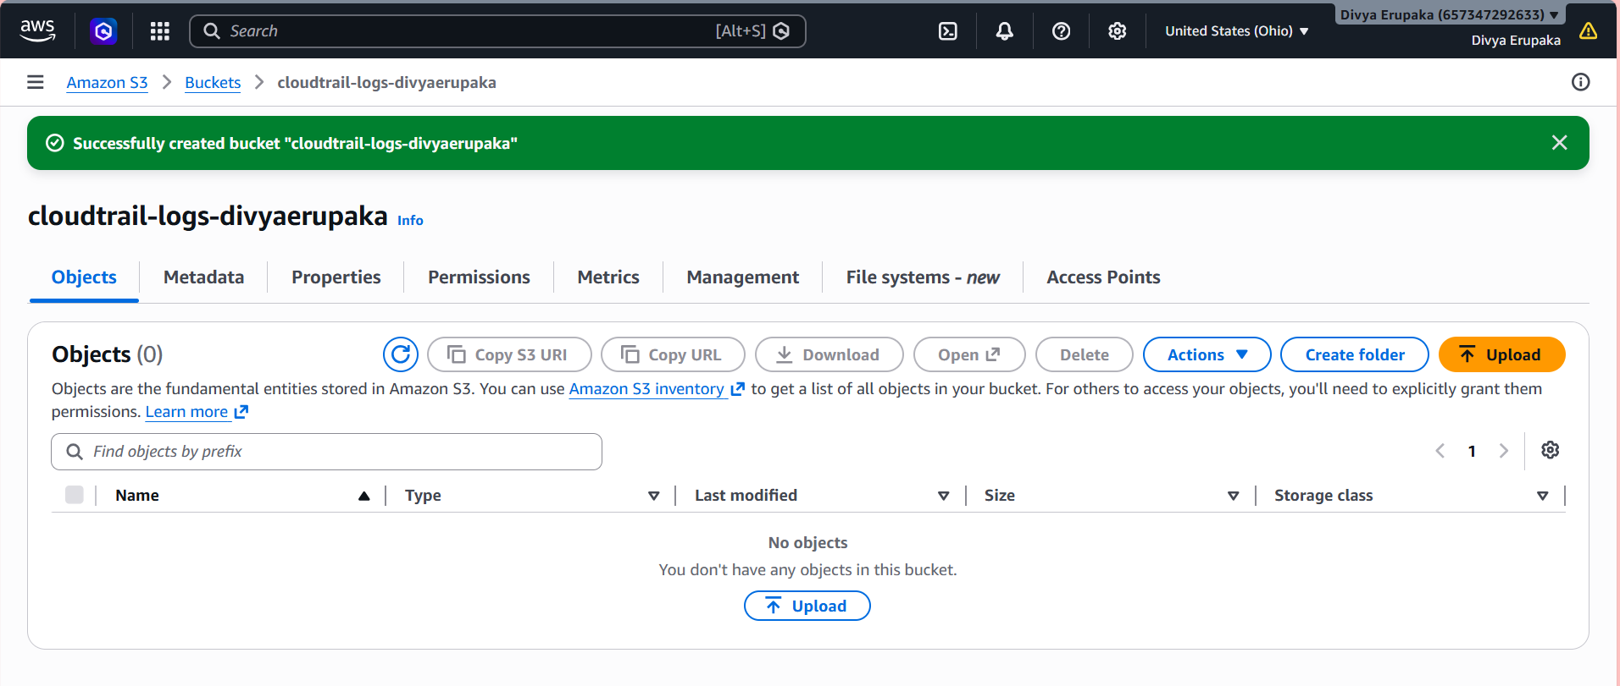
Step 2: Enable CloudTrail
- Go to AWS Console → CloudTrail
- Click Create trail
- Enter:
  - Trail name: org-cloudtrail
  - Apply trail to all regions: Yes (recommended)
- Storage location:
  - Select Existing S3 bucket
  - Choose the bucket created above
- Enable:
  - Log file validation
  - CloudWatch Logs integration (important)
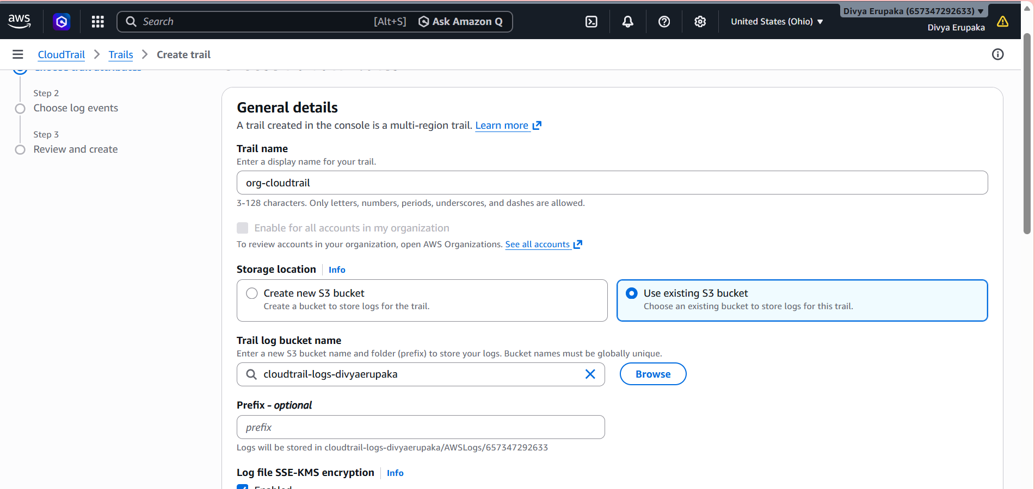
Step 3: Configure CloudWatch Logs Integration
- In CloudTrail settings, enable:
  - Send to CloudWatch Logs
- Create or select IAM role:
  - Role name: CloudTrail_CloudWatch_Role
- Specify Log Group:
  - /aws/cloudtrail/logs
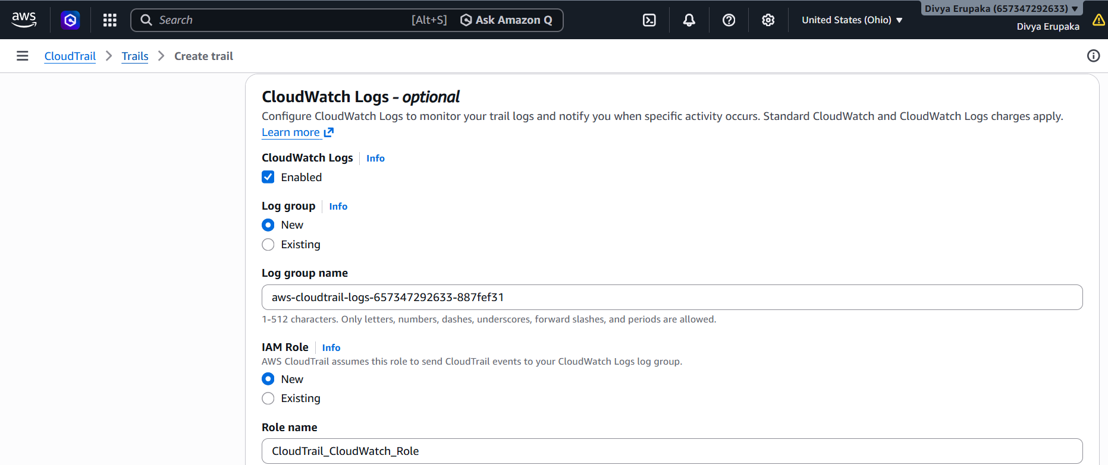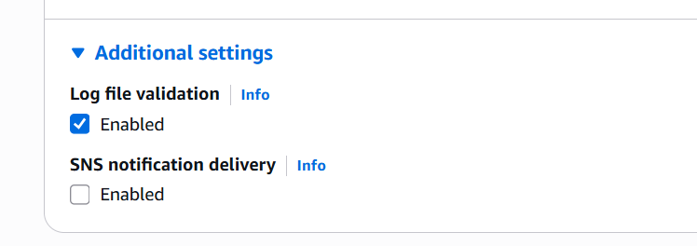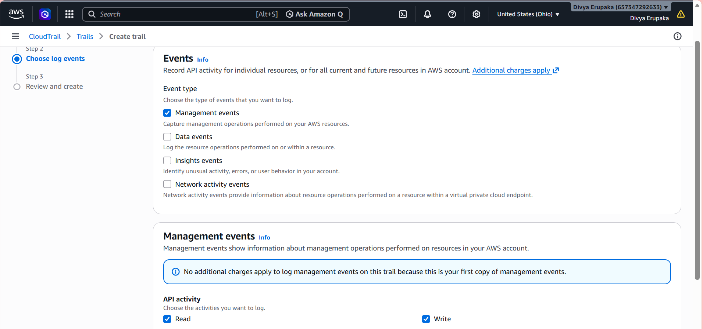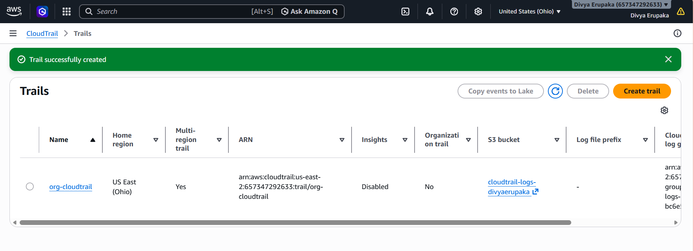
Step 4: Verify CloudTrail Logging
- Go to CloudTrail → Event History
- Perform an action (example: launch EC2 instance or create S3 bucket)
- Check if events appear in:
  - Event History
  - S3 bucket logs
  - CloudWatch Logs
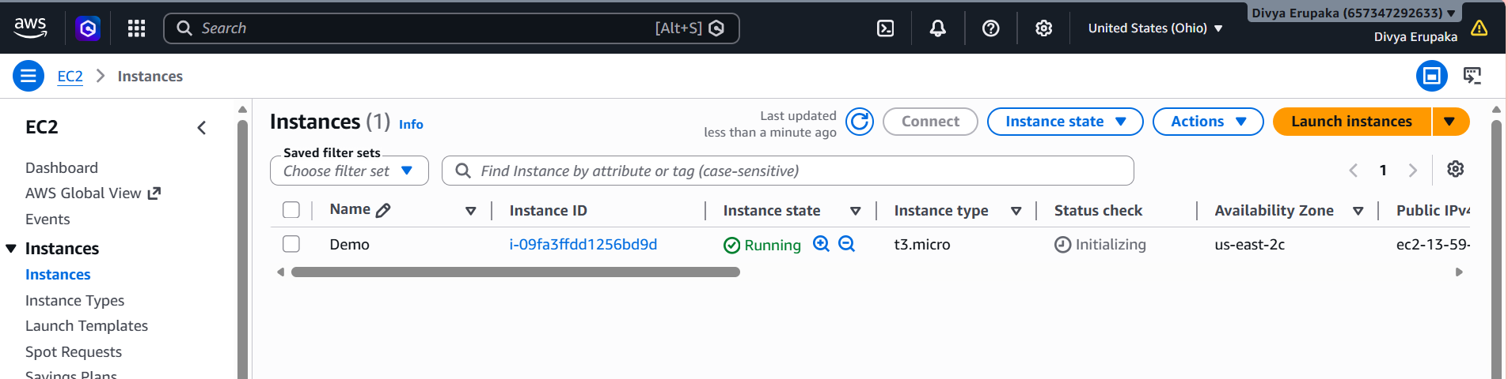
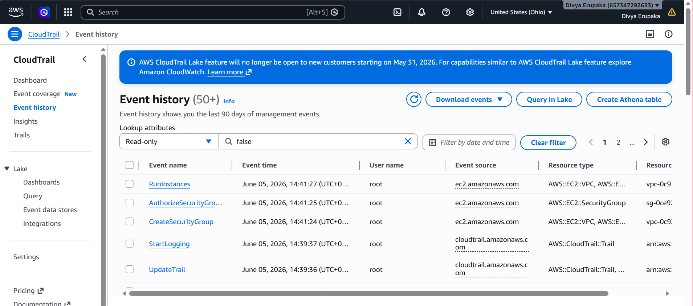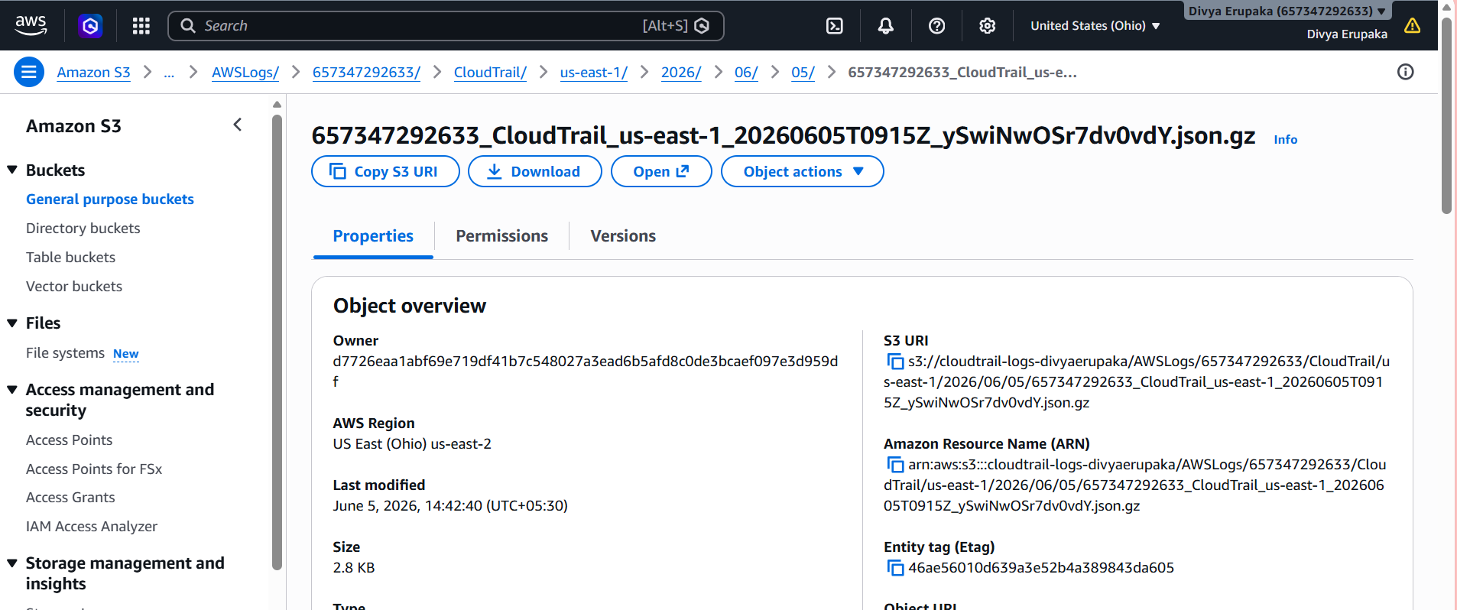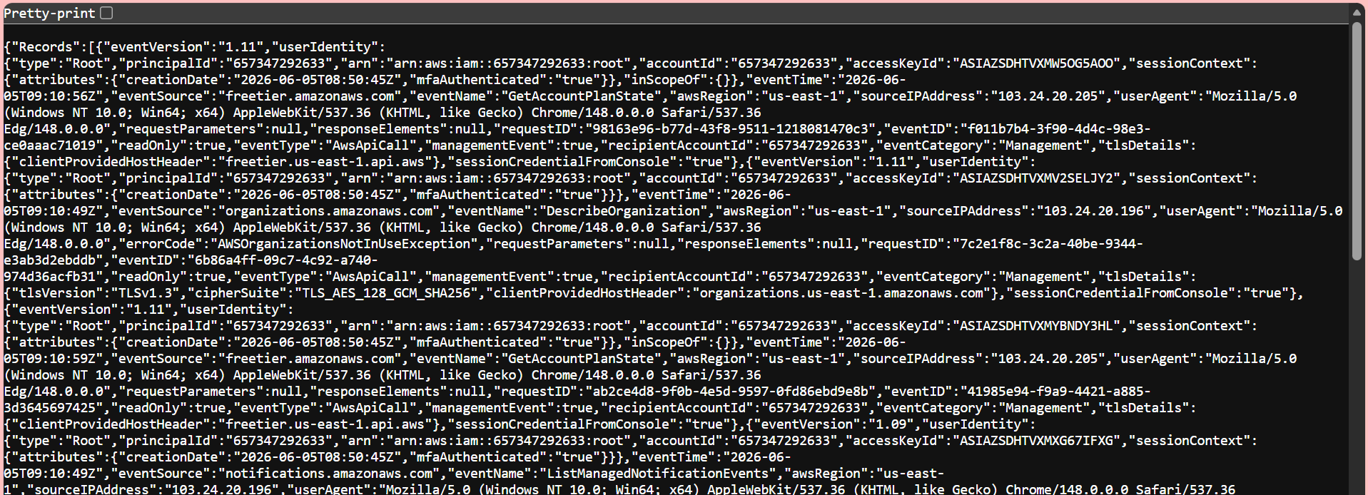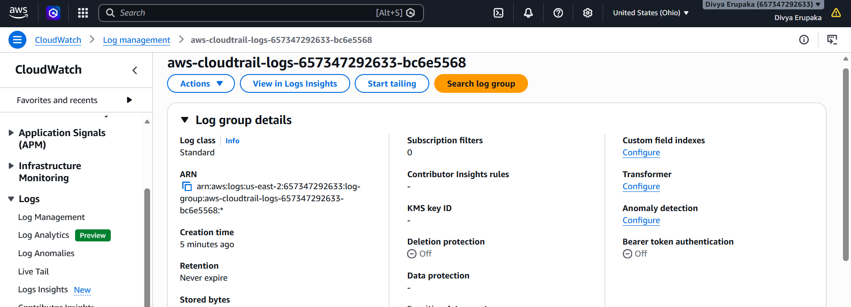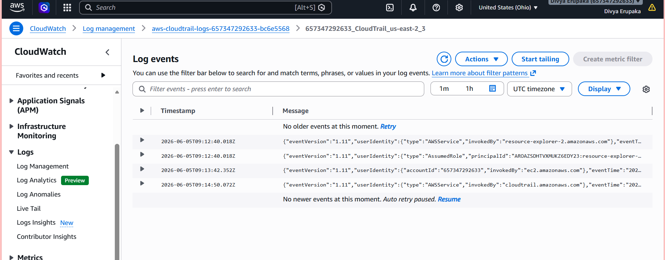
6. Output / Result
- CloudTrail successfully enabled
- Logs are stored in S3 bucket
- Real-time logs are streamed to CloudWatch Logs
- AWS API activities are tracked and monitored

7. Key Benefits
- Auditing AWS account activity
- Security monitoring
- Compliance tracking
- Real-time alerting using CloudWatch

8. Conclusion
CloudTrail has been successfully configured to record all AWS API activities. Logs are securely stored in Amazon S3 and simultaneously monitored using Amazon CloudWatch Logs for real-time analysis and security insights.
Task 2: Enable SNS for CloudTrail to Send Alerts via Email
1. Objective
To configure Amazon SNS (Simple Notification Service) so that email notifications are sent whenever specific CloudTrail events are detected. This helps administrators receive immediate alerts about important activities occurring in the AWS account.
2. AWS Services Used
- AWS CloudTrail
- Amazon CloudWatch Logs
- Amazon CloudWatch Alarms
- Amazon SNS
- Email Service
3. Pre-Requisites
- CloudTrail enabled and logging to CloudWatch Logs (Task 1 completed)
- Administrator access to AWS account
- Valid email address for notifications
4. Implementation Steps
Step 1: Create an SNS Topic
- Login to AWS Console.
- Navigate to SNS.
- Click Topics.
- Click Create Topic.
- Select Standard Topic.
- Enter:
Parameter | Value
Type | Standard
Name | CloudTrail-Alerts
- Click Create Topic.
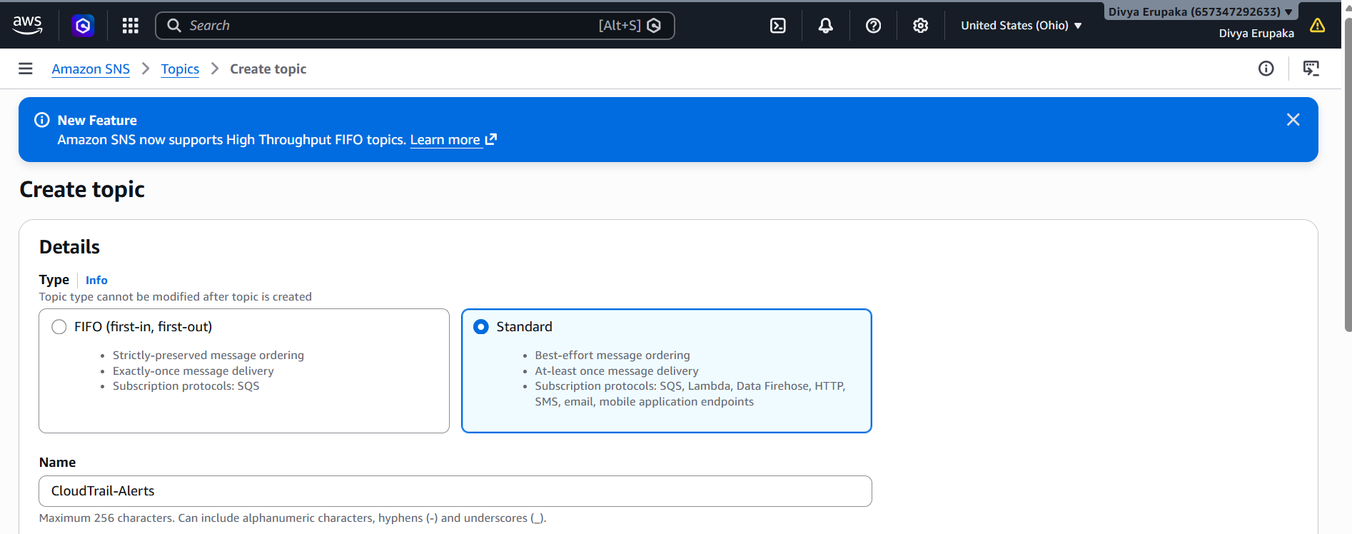
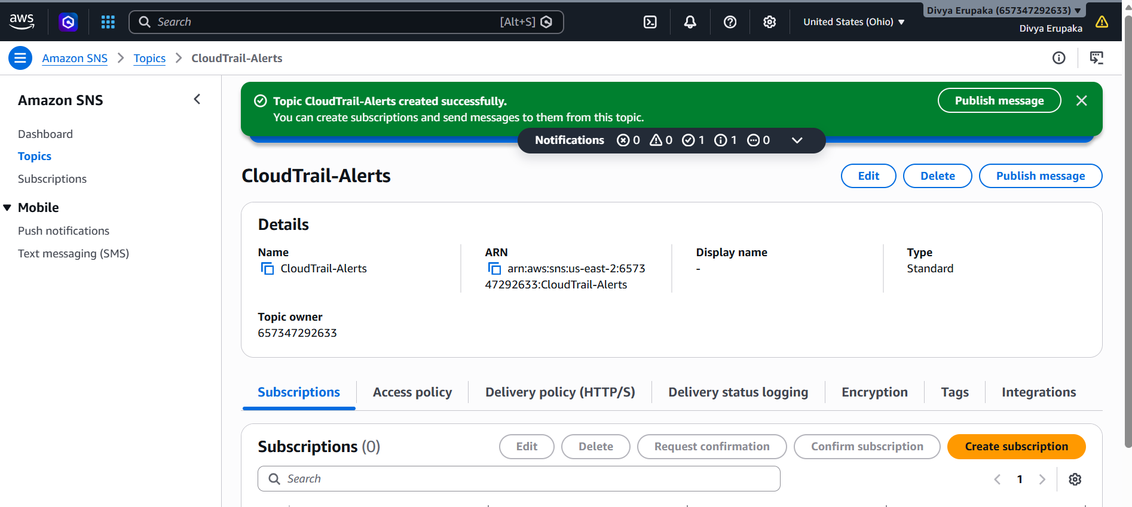Step 2: Create Email Subscription
- Open the created SNS Topic.
- Click Create Subscription.
- Configure:
Parameter | Value
Protocol | Email
Endpoint | your-email@example.com
- Click Create Subscription.
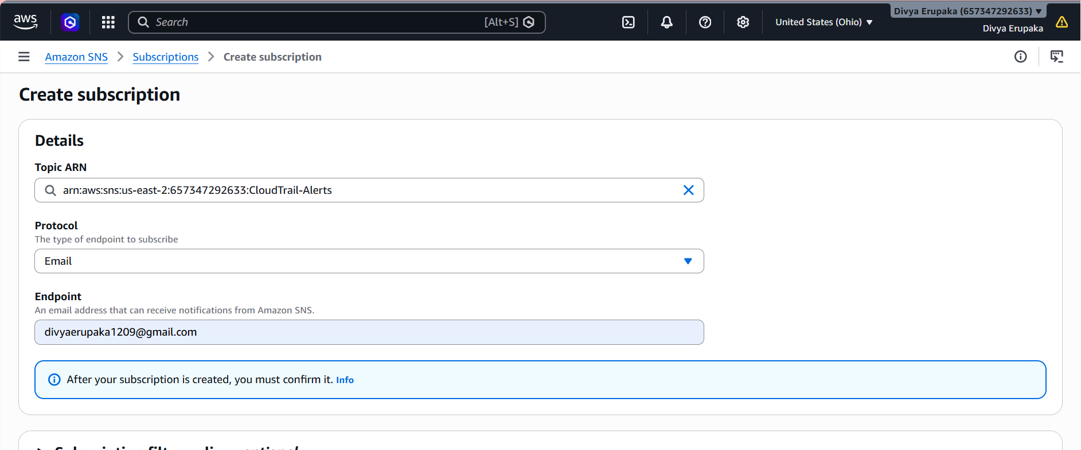
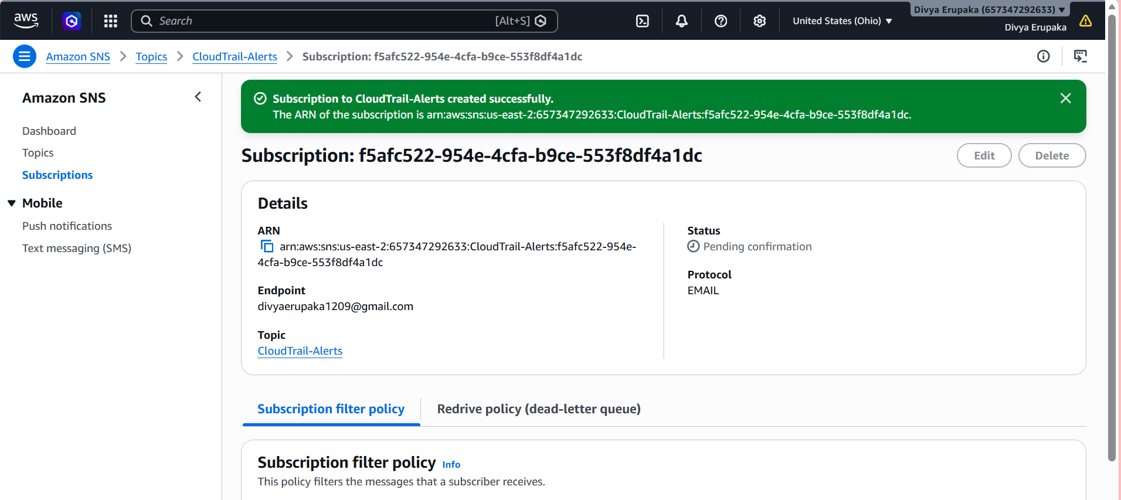
Step 3: Confirm Subscription
- Check your email inbox.
- Open the email received from AWS SNS.
- Click Confirm Subscription.
After confirmation, the subscription status changes from:
Pending Confirmation
to
Confirmed
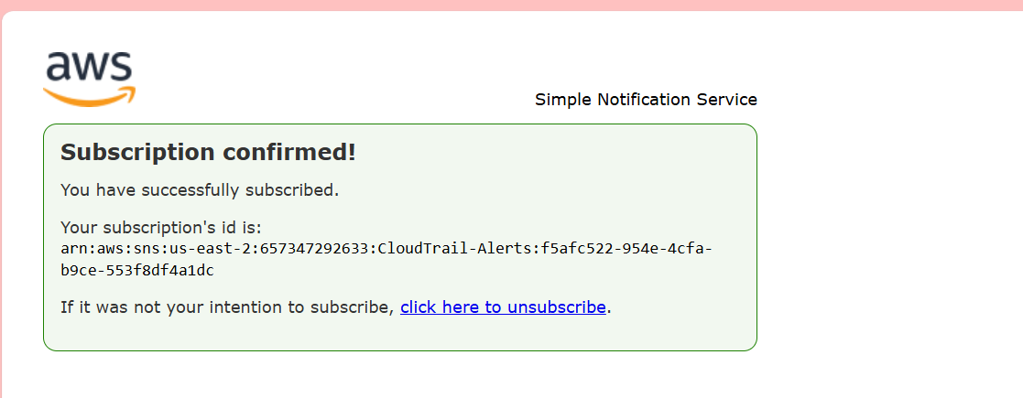
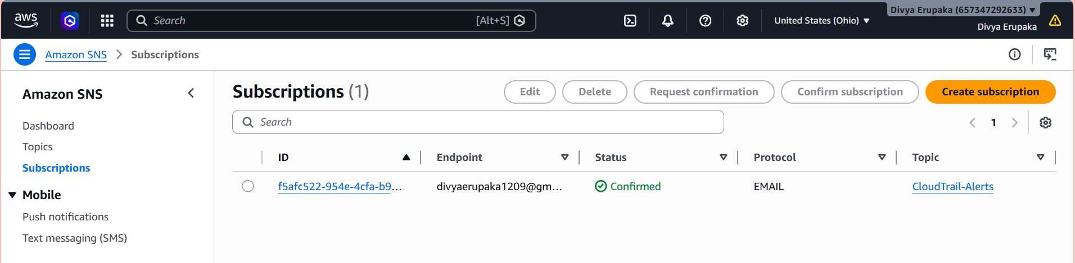
Step 4: Configure CloudTrail to Use SNS
1. Opened AWS CloudTrail.
2. Selected the existing trail:
cloudtrail-monitoring
3. Clicked Edit.
4. Scrolled to Additional Settings.
5. Enabled:
SNS Notification Delivery
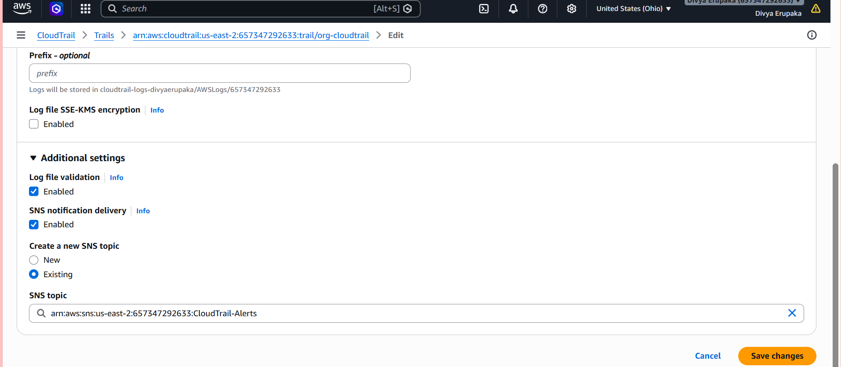
6. Selected:
Existing SNS Topic
7. Chose the SNS topic:
CloudTrail-Alerts
- Saved the changes.
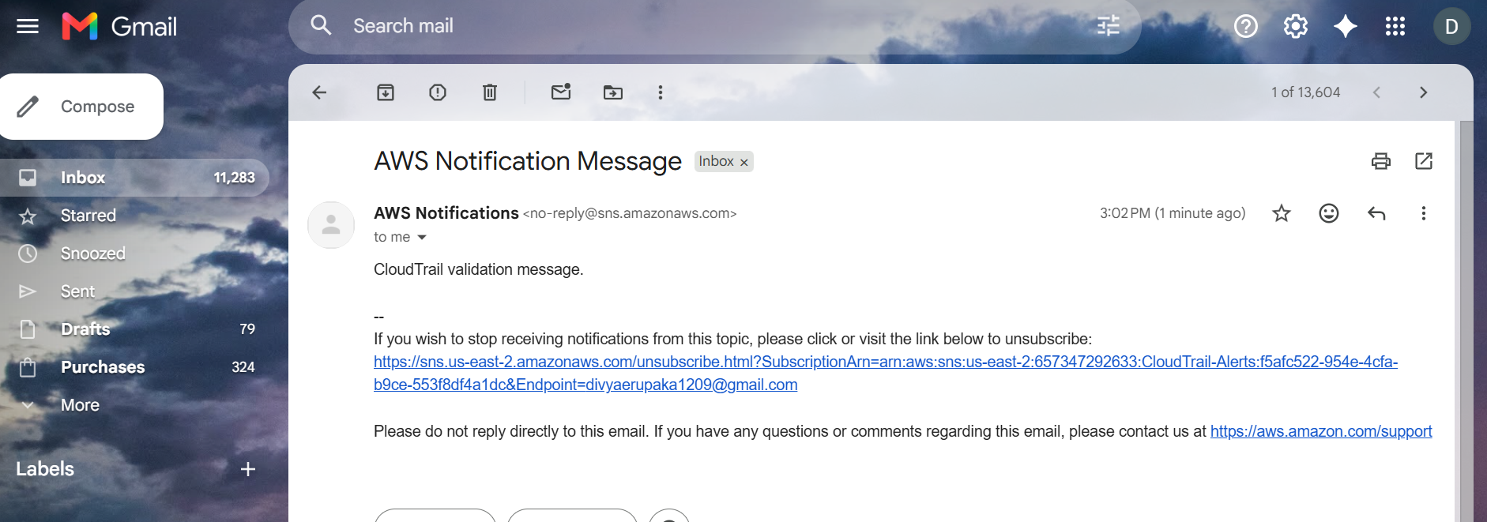
Purpose
This configuration allows CloudTrail to send notifications to SNS whenever log files are delivered.
Step 5: Verify SNS Notifications
1. Waited for CloudTrail to generate log files.
2. Checked the subscribed Gmail inbox.
3. Received multiple emails from:
AWS Notifications
4. Verified that the email contained CloudTrail log delivery details such as:
s3Bucket : aws-cloudtrail-logs-679730213729-5626dfe4
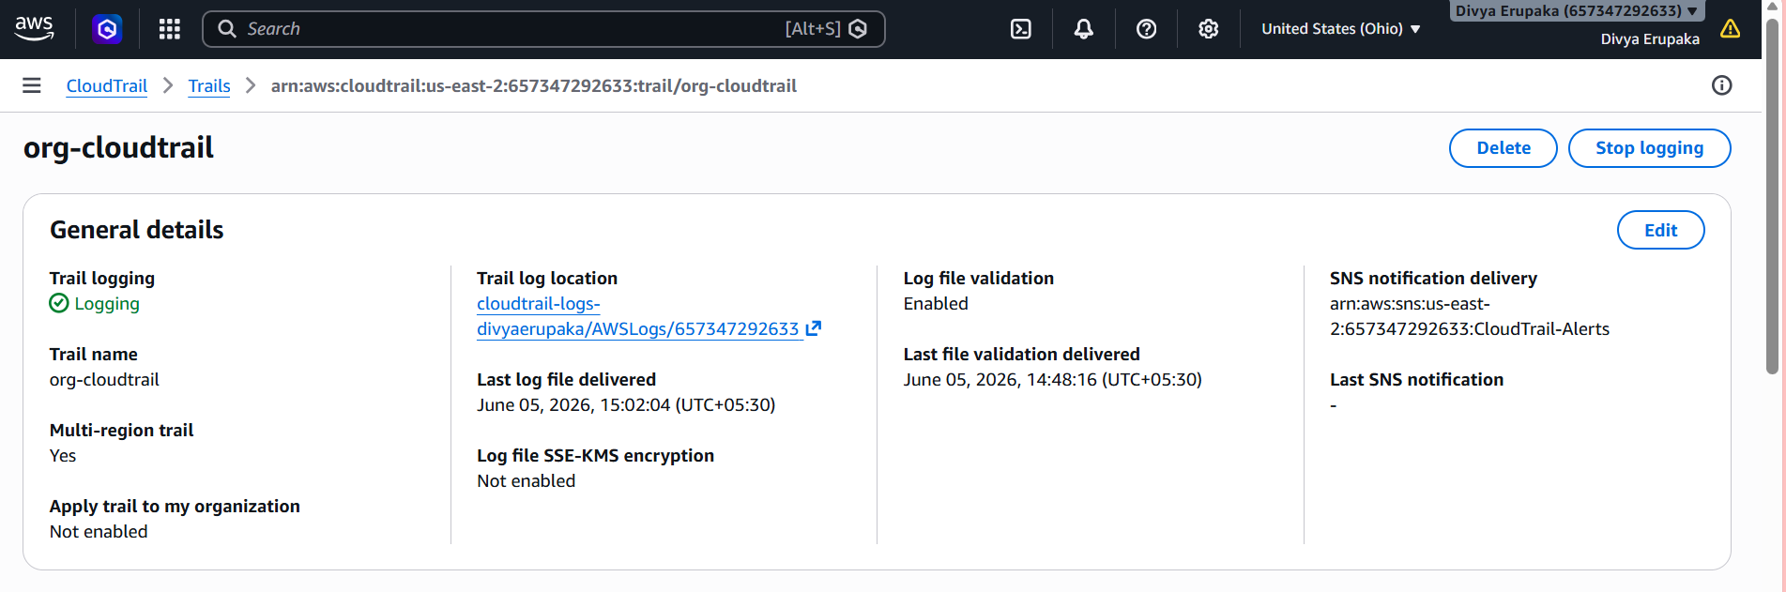
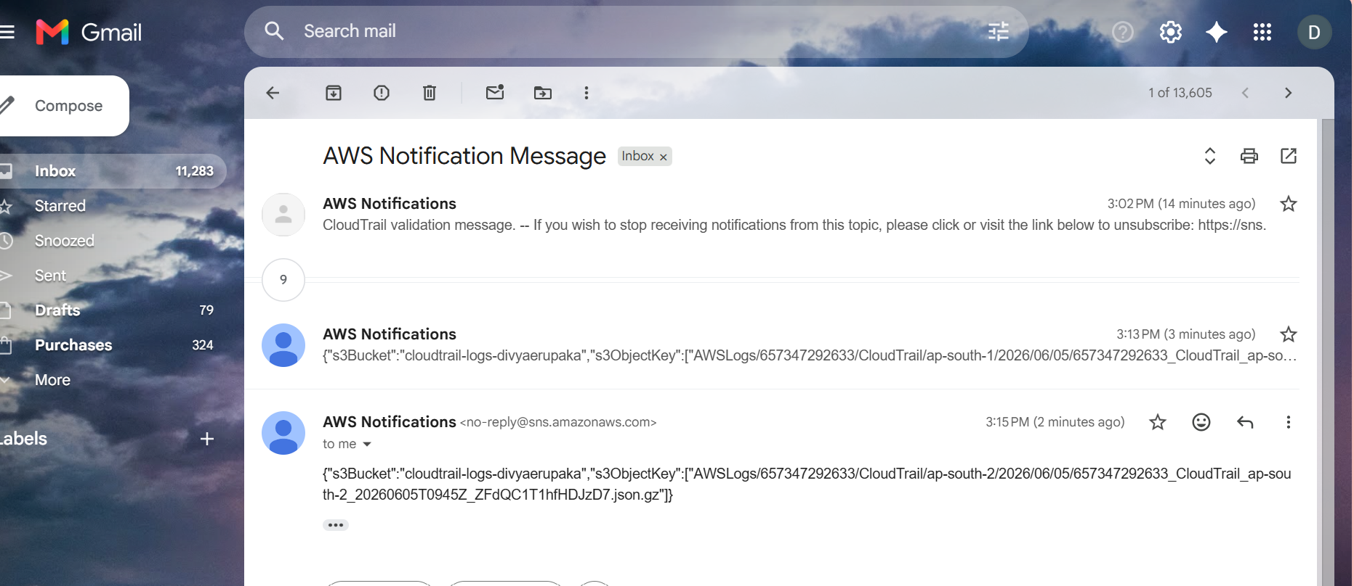
Architecture
CloudTrail
|
v
SNS Topic (CloudTrail-Alerts)
|
v
Email Subscription
|
v
Email Notification
Result
Successfully configured Amazon SNS with AWS CloudTrail. Created an SNS topic, subscribed an email endpoint, confirmed the subscription, and integrated the SNS topic with the CloudTrail trail. Verified successful email delivery by receiving CloudTrail log delivery notifications in the subscribed email account.
Task 3: Configure CloudWatch Monitoring and Record CPU Utilization and Other Metrics of EC2
Objective
To configure Amazon CloudWatch monitoring for an EC2 instance and observe key performance metrics such as CPU Utilization, Network Traffic, Disk Operations, and Status Checks. This enables continuous monitoring of instance health and resource usage.

AWS Services Used
- Amazon EC2
- Amazon CloudWatch
- IAM

Pre-Requisites
- AWS Account with appropriate permissions.
- Running EC2 Instance.
- Access to Amazon CloudWatch.
- Internet connectivity to access AWS services.

Implementation Steps
Step 1: Launch or Select an EC2 Instance
- Logged in to the AWS Management Console.
- Navigated to EC2 Dashboard.
- Selected an existing EC2 instance for monitoring.
Example Instance Details:
Parameter | Value
Instance Name | CloudWatch-Test-Server
Instance Type | t2.micro
Operating System | Amazon Linux
Instance State | Running
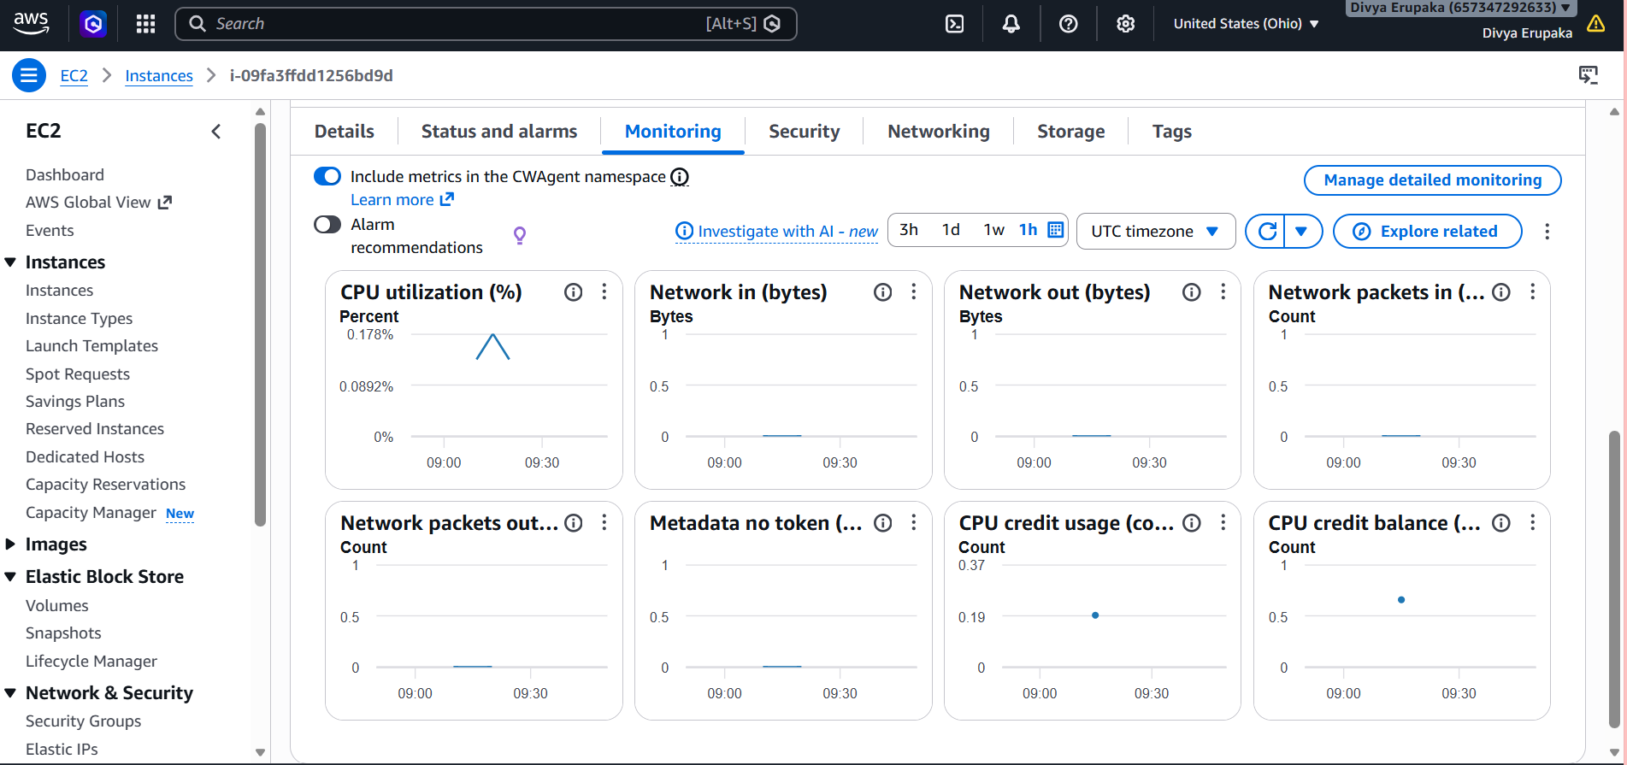
Step 2: Verify Default CloudWatch Monitoring
- Navigated to:
EC2 → Instances
- Selected the EC2 instance.
- Opened the Monitoring tab.
Observed default CloudWatch metrics:
- CPU Utilization
- Network In
- Network Out
- Disk Read Bytes
- Disk Write Bytes
- Status Check Failed
Evidence: Screenshot of Monitoring Tab.

Step 3: Enable Detailed Monitoring
By default, EC2 sends metrics to CloudWatch every 5 minutes.
To collect metrics every 1 minute:
- Selected the EC2 instance.
- Clicked:
Actions → Monitor and Troubleshoot → Manage Detailed Monitoring
- Selected:
Enable Detailed Monitoring
- Saved the configuration.
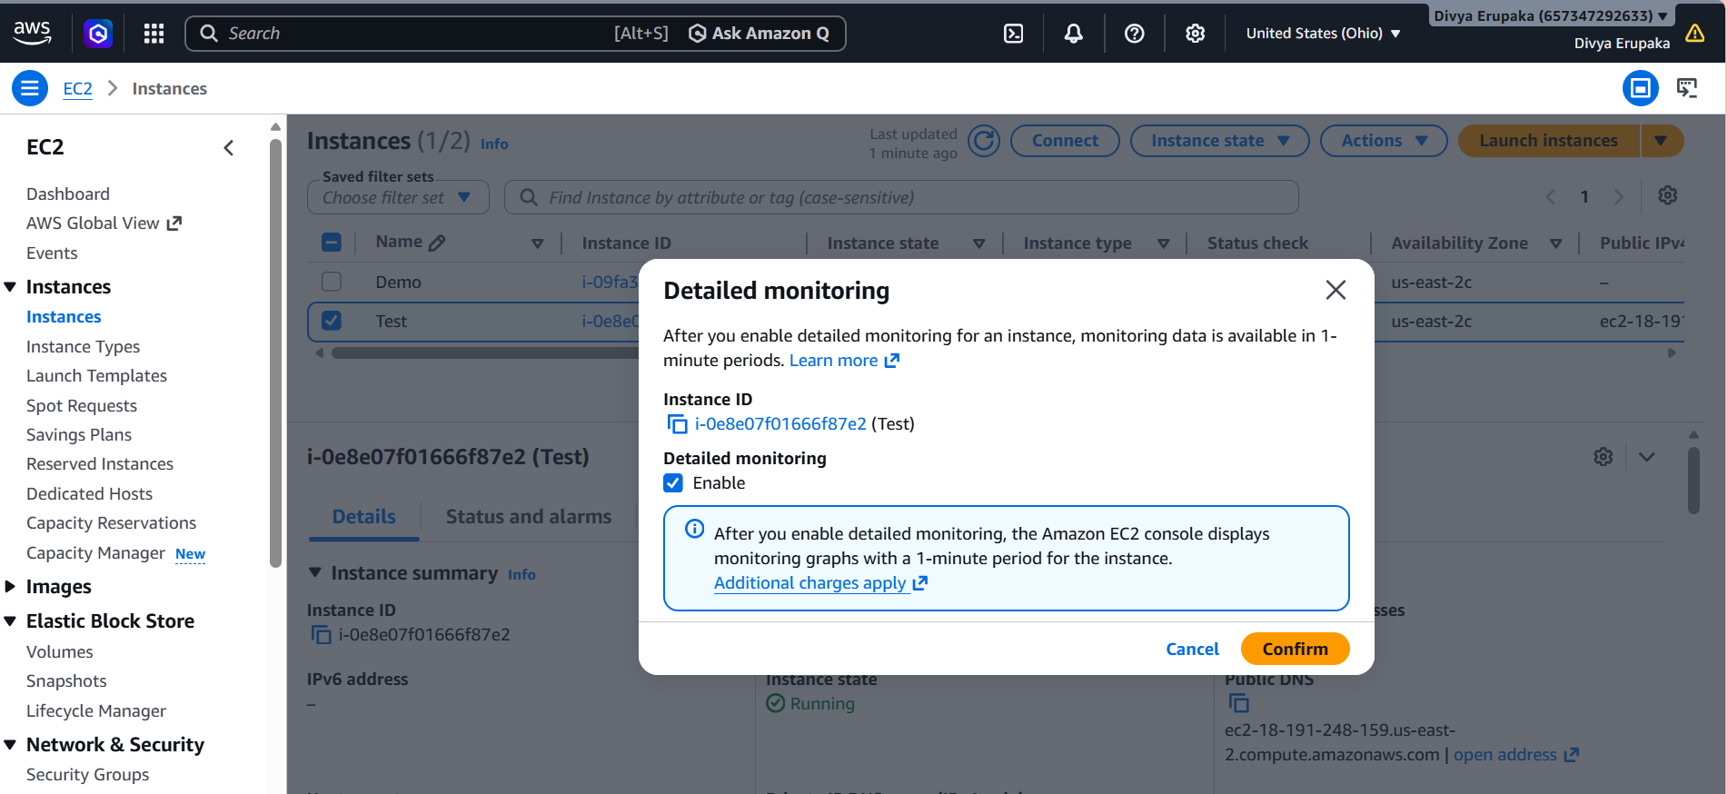Step 4: View Metrics in CloudWatch
- Navigated to:
CloudWatch → Metrics
- Selected:
EC2 → Per-Instance Metrics
- Chose the target EC2 instance.
Observed the following metrics:
Metric | Description
CPUUtilization | Percentage of CPU usage
NetworkIn | Incoming network traffic
NetworkOut | Outgoing network traffic
DiskReadBytes | Data read from disk
DiskWriteBytes | Data written to disk
StatusCheckFailed | Instance health status
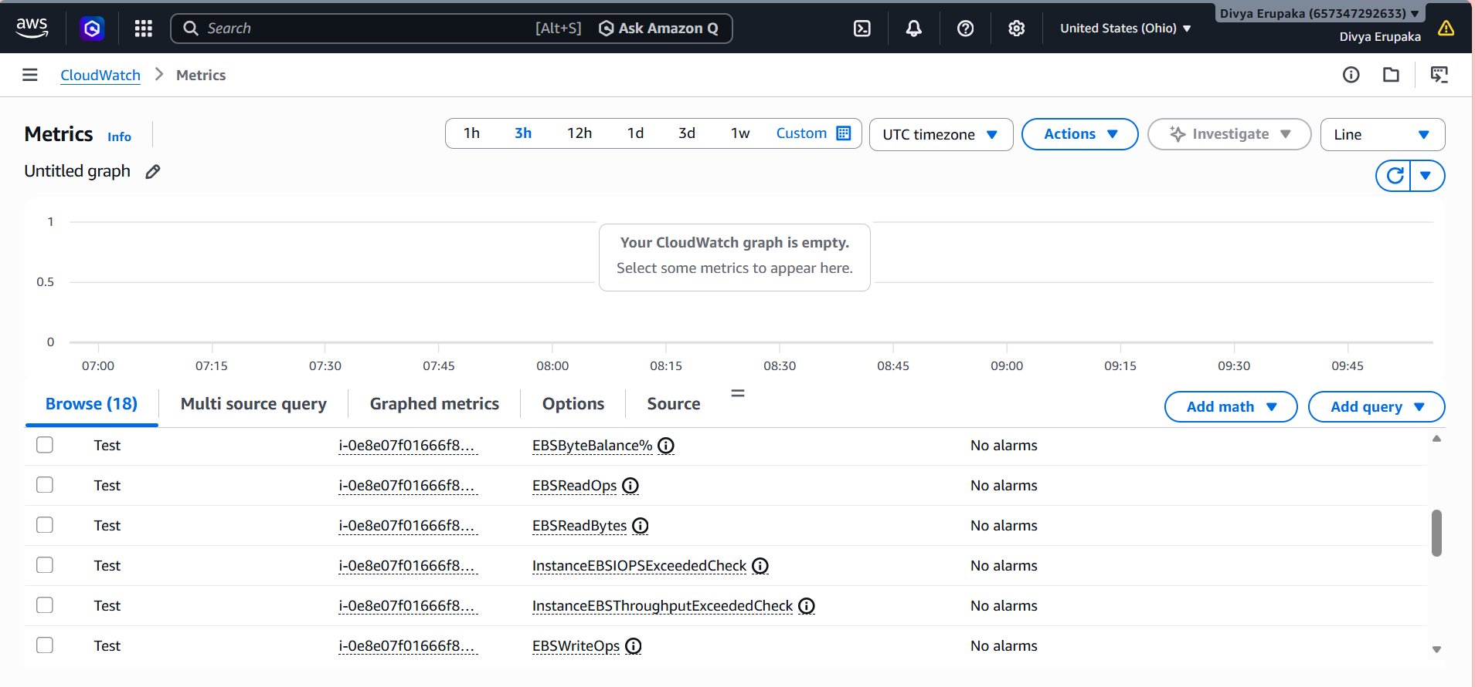Step 5: Generate Activity on the EC2 Instance
- Connected to the EC2 instance using SSH.
ssh -i mykey.pem ec2-user@<public-ip>
- Installed the stress utility:
sudo yum install stress -y
- Generated CPU load:
stress --cpu 2 --timeout 300
- Allowed the command to run for 5 minutes.
Purpose:
- Simulate workload on the instance.
- Increase CPU utilization for monitoring.
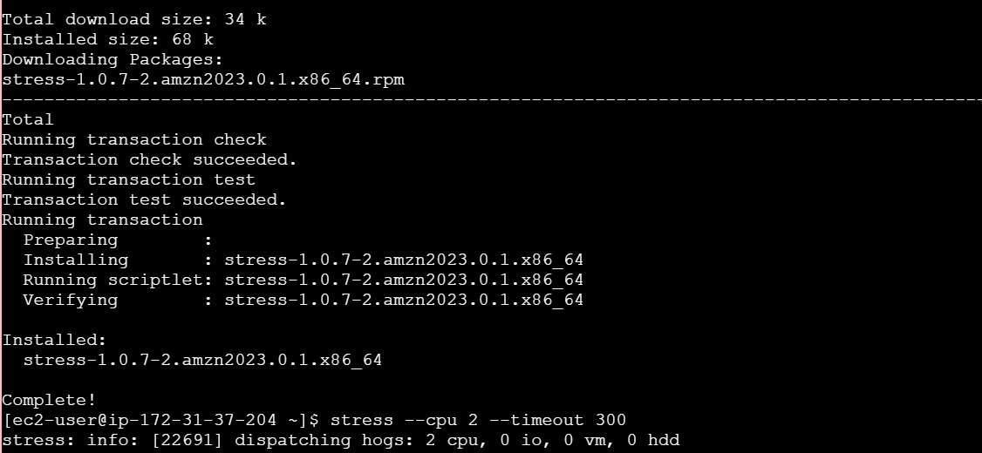Step 6: Verify CPU Utilization Metric
- Opened:
CloudWatch → Metrics → EC2
- Selected the CPUUtilization metric.
- Verified that CPU usage increased during the stress test.
Observed:
- CPU utilization spike visible in CloudWatch graphs.
- Metrics updated every minute due to detailed monitoring.
Evidence: Screenshot of CPU Utilization graph.
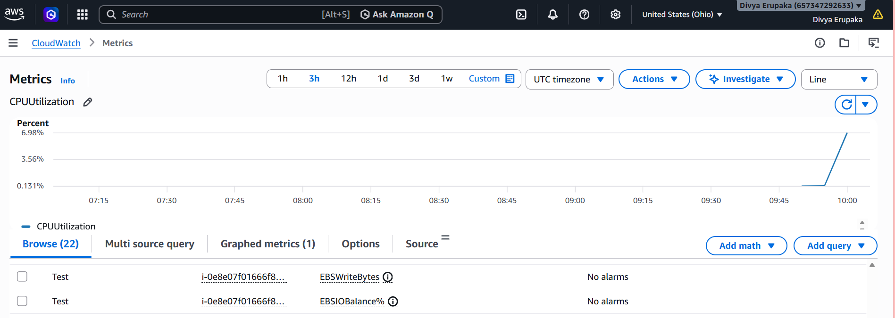
Step 7: Monitor Additional Metrics
Verified the following metrics in CloudWatch:
Network In
Measures incoming traffic received by the EC2 instance.
Network Out
Measures outgoing traffic sent from the EC2 instance.
Disk Read Bytes
Measures the amount of data read from attached storage.
Disk Write Bytes
Measures the amount of data written to attached storage.
Status Check Failed
Monitors instance and system health checks.
Evidence: Screenshots of individual metric graphs.

Step 8: Create a CloudWatch Dashboard
- Navigated to:
CloudWatch → Dashboards
- Clicked Create Dashboard.
- Dashboard Name:
EC2-Monitoring-Dashboard
- Added widgets for:
- CPU Utilization
- Network In
- Network Out
- Disk Read Bytes
- Disk Write Bytes
- Saved the dashboard.
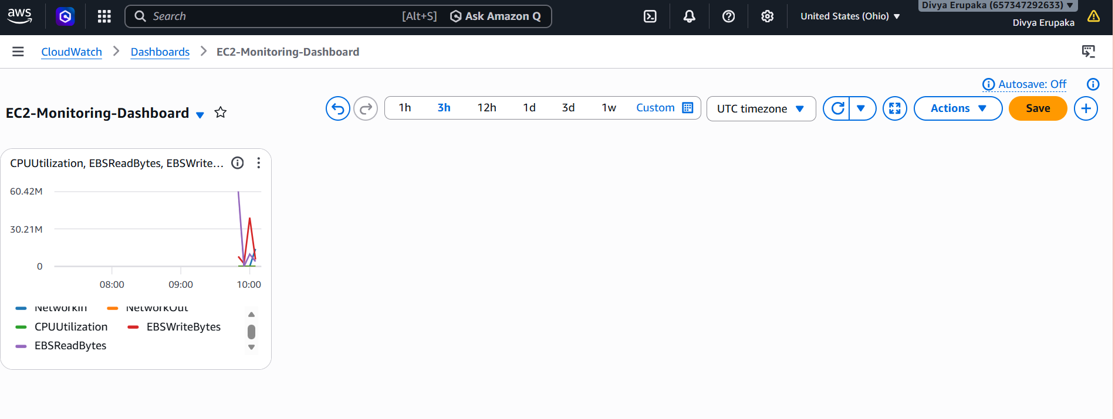Metrics Recorded
CPU Utilization
Represents the percentage of allocated EC2 compute resources currently in use.
Network In
Tracks incoming network traffic to the instance.
Network Out
Tracks outgoing network traffic from the instance.
Disk Read Bytes
Tracks the amount of data read from storage.
Disk Write Bytes
Tracks the amount of data written to storage.
Status Check Failed
Indicates whether the instance passed AWS health checks.

Result
Successfully configured Amazon CloudWatch monitoring for the EC2 instance.
Verified collection of the following metrics:
✔ CPU Utilization
✔ Network In
✔ Network Out
✔ Disk Read Bytes
✔ Disk Write Bytes
✔ Status Check Metrics
✔ CloudWatch Dashboard Visualization

Conclusion
Amazon CloudWatch monitoring was successfully configured for the EC2 instance. CPU Utilization and other important performance metrics were collected and monitored through CloudWatch. Detailed monitoring provided near real-time visibility into instance performance, enabling proactive monitoring and troubleshooting of AWS infrastructure.
Task 4: Create a CloudWatch Alarm to Send an Email Alert When CPU Utilization Exceeds 70%
Objective
To create an Amazon CloudWatch Alarm that monitors EC2 CPU Utilization and sends an email notification whenever CPU usage exceeds 70%. This helps administrators proactively identify high resource utilization and take corrective action.

AWS Services Used
- Amazon EC2
- Amazon CloudWatch
- Amazon SNS (Simple Notification Service)
- Email Service

Pre-Requisites
- Running EC2 Instance.
- CloudWatch monitoring enabled on the EC2 instance.
- SNS Topic configured with a confirmed email subscription.
- Appropriate IAM permissions.

Implementation Steps
Step 1: Verify SNS Topic Availability
- Logged in to the AWS Management Console.
- Navigated to Amazon SNS.
- Verified the existing SNS Topic:
Parameter | Value
Topic Name | EC2-CPU-Alerts
Subscription Status | Confirmed
- Confirmed that the email subscription was active.
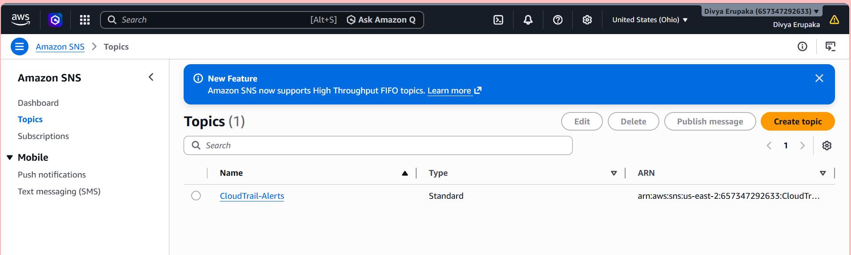
Step 2: Open CloudWatch Alarms
- Navigated to:
CloudWatch → Alarms
- Clicked Create Alarm.
Evidence: Screenshot of CloudWatch Alarms page.
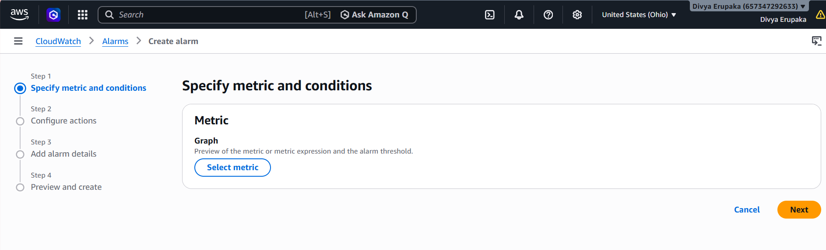
Step 3: Select EC2 CPU Utilization Metric
- Clicked Select Metric.
- Navigated to:
EC2 → Per-Instance Metrics
- Selected the target EC2 instance.
- Chose the metric:
CPUUtilization
- Clicked Select Metric.
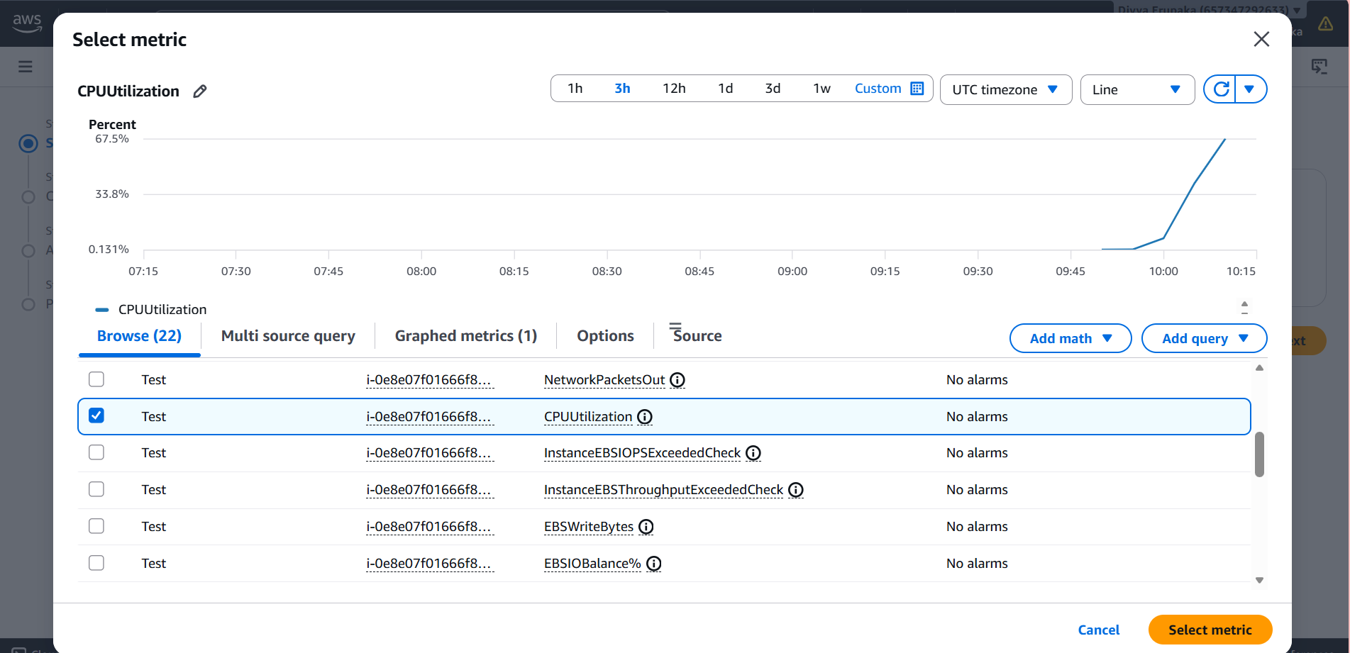
Step 4: Configure Alarm Conditions
Configured the following alarm settings:
Parameter | Value
Statistic | Average
Period | 5 Minutes
Threshold Type | Static
Condition | Greater Than
Threshold Value | 70
Meaning:
- Alarm triggers when CPU utilization exceeds 70%.
- Evaluation is based on the average CPU utilization during the selected period.
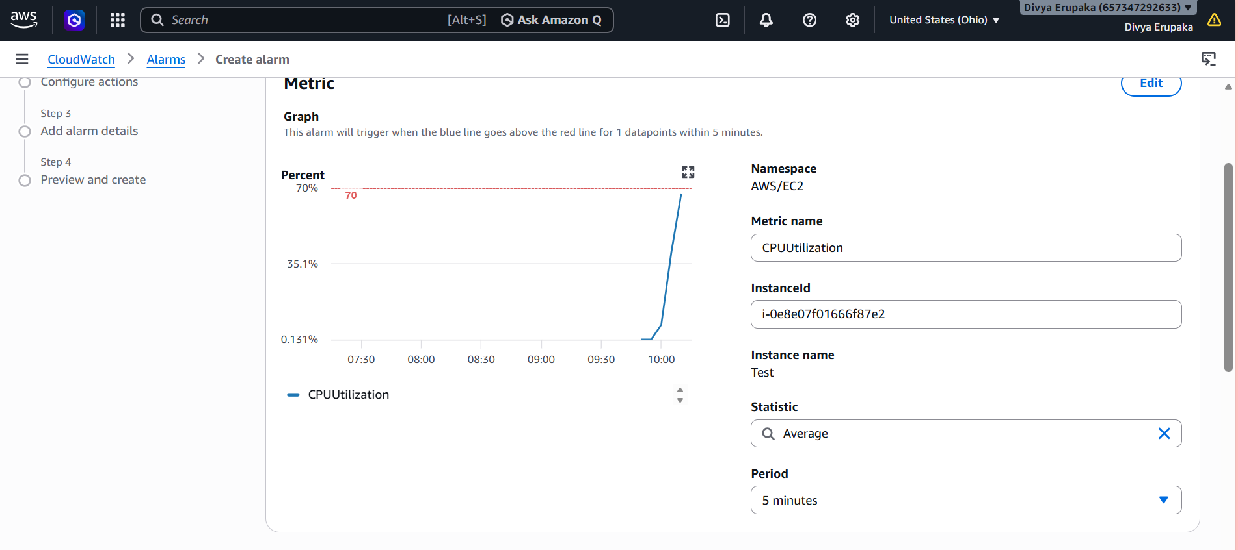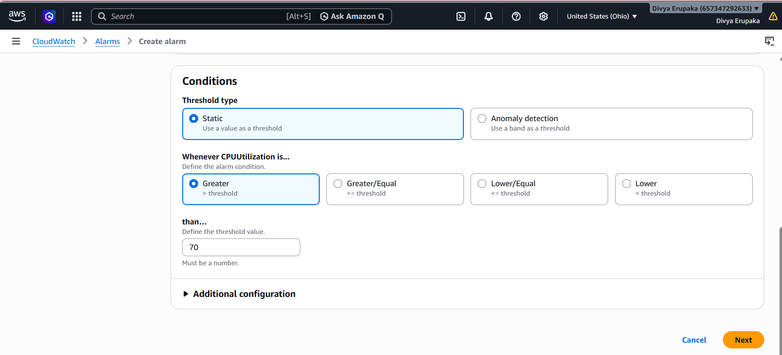
Step 5: Configure Notification Action
- Under Notification Actions, selected:
In Alarm
- Chose:
Send notification to an existing SNS topic
- Selected SNS Topic:
EC2-CPU-Alerts
- Clicked Next.
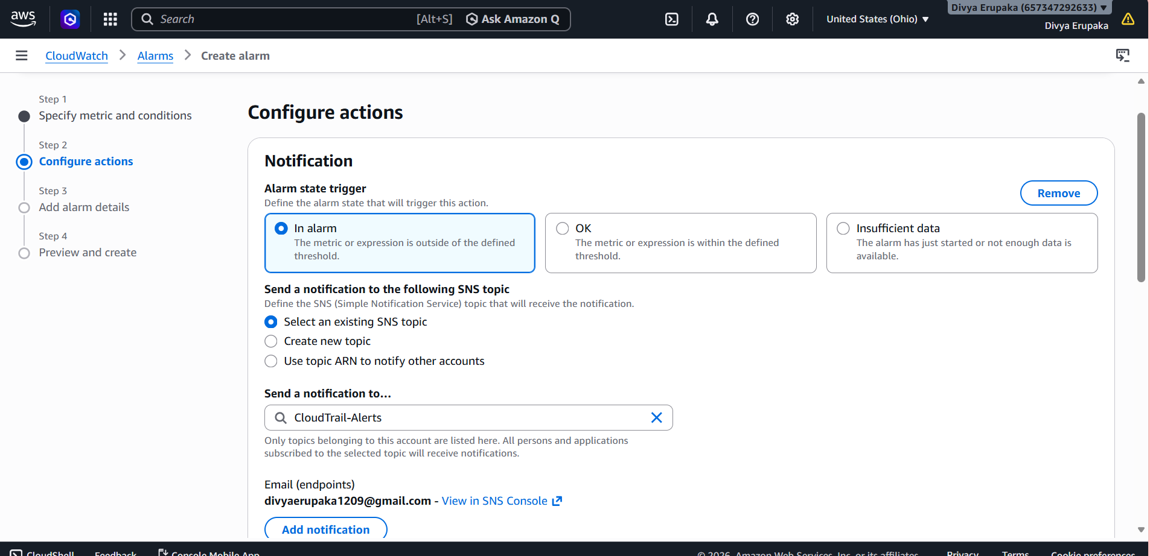
Step 6: Configure Alarm Name
Entered:
Parameter | Value
Alarm Name | EC2-High-CPU-Alarm
Description | Alert when CPU utilization exceeds 70%
Clicked Next and then Create Alarm.
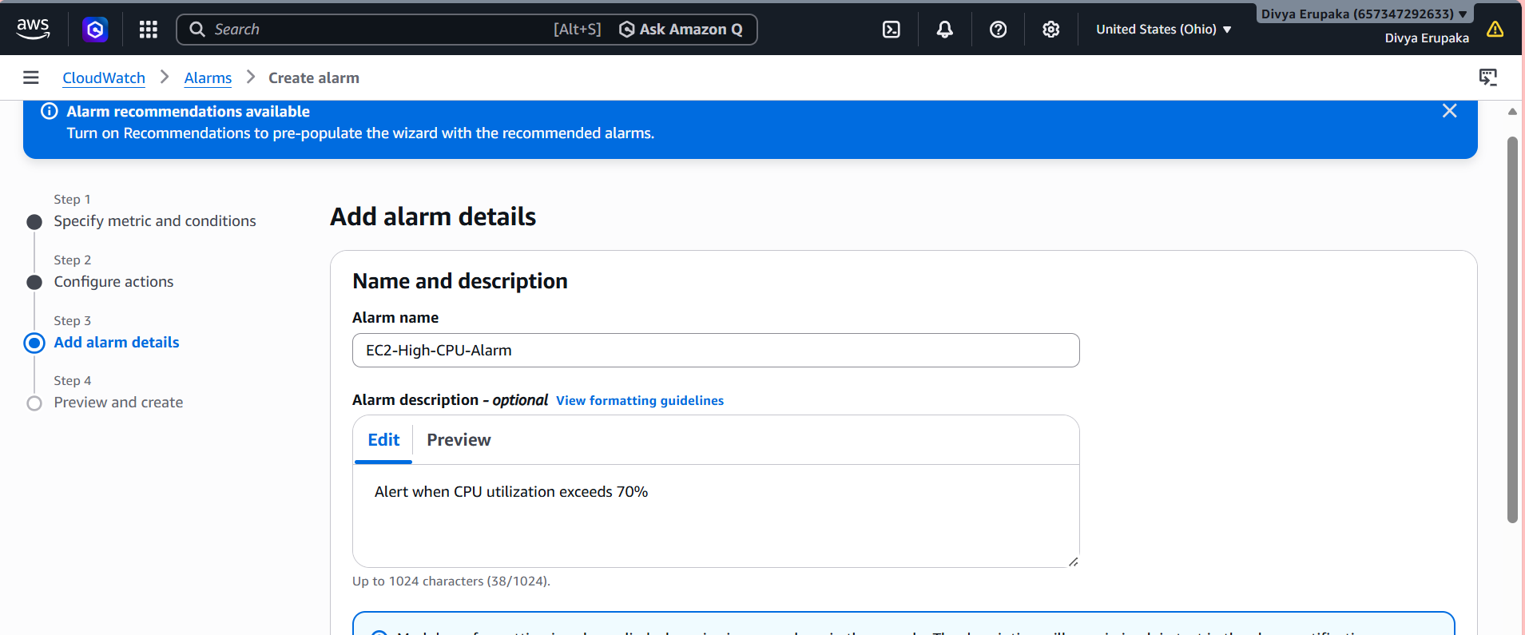
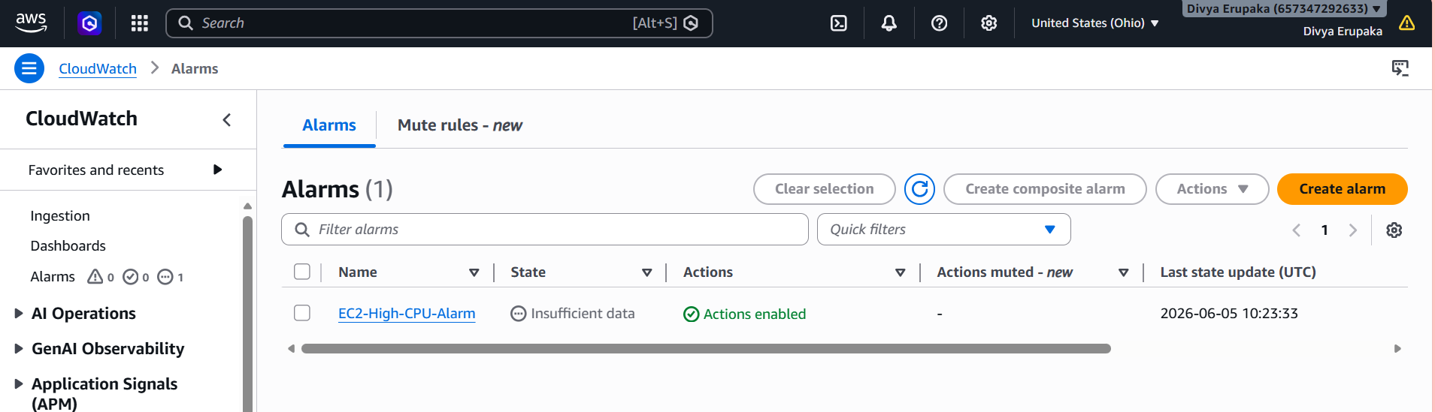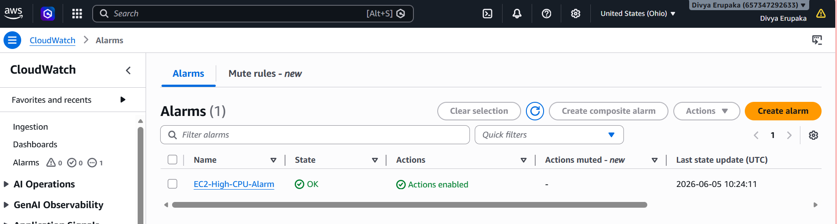
Step 7: Generate CPU Load for Testing
Connected to the EC2 instance using SSH.
Executed the following command:
stress --cpu 2 --timeout 300
Purpose:
- Generate CPU-intensive workload.
- Increase CPU utilization above 70%.
- Trigger the CloudWatch alarm.
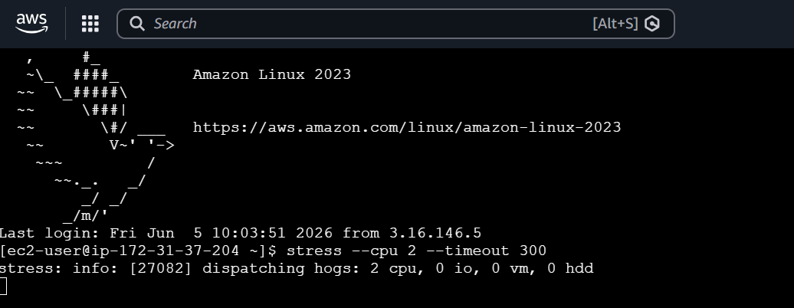
Step 8: Verify Alarm Trigger
- Opened:
CloudWatch → Alarms
- Observed the alarm state change:
OK → ALARM
- Verified that CPU utilization exceeded the configured threshold.
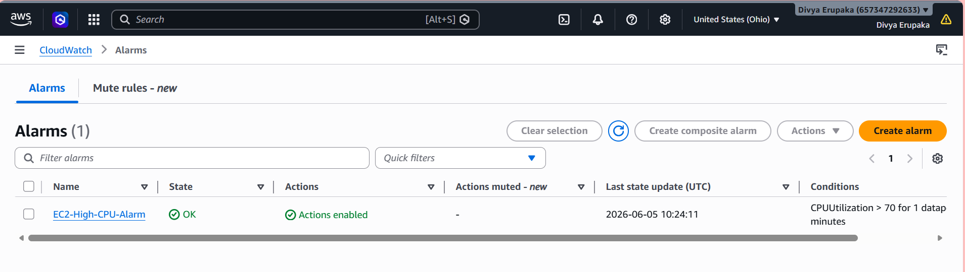
Step 9: Verify Email Notification
- Checked the subscribed email inbox.
- Received an email notification from AWS.
Example message:
You are receiving this email because your Amazon CloudWatch Alarm
"EC2-High-CPU-Alarm" has entered the ALARM state.

Reason:
Threshold Crossed: CPUUtilization exceeded 70%.
- Verified the alarm details and timestamp.
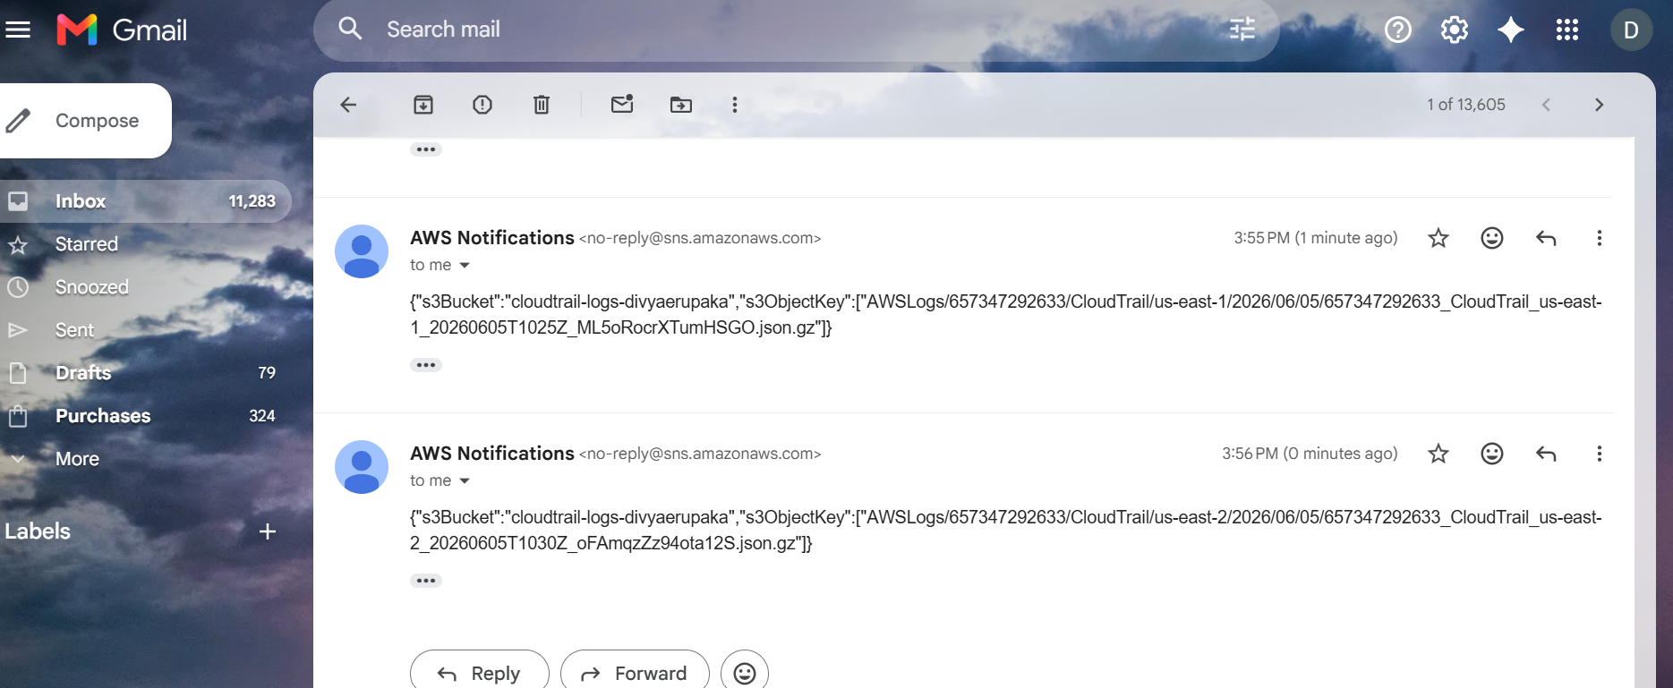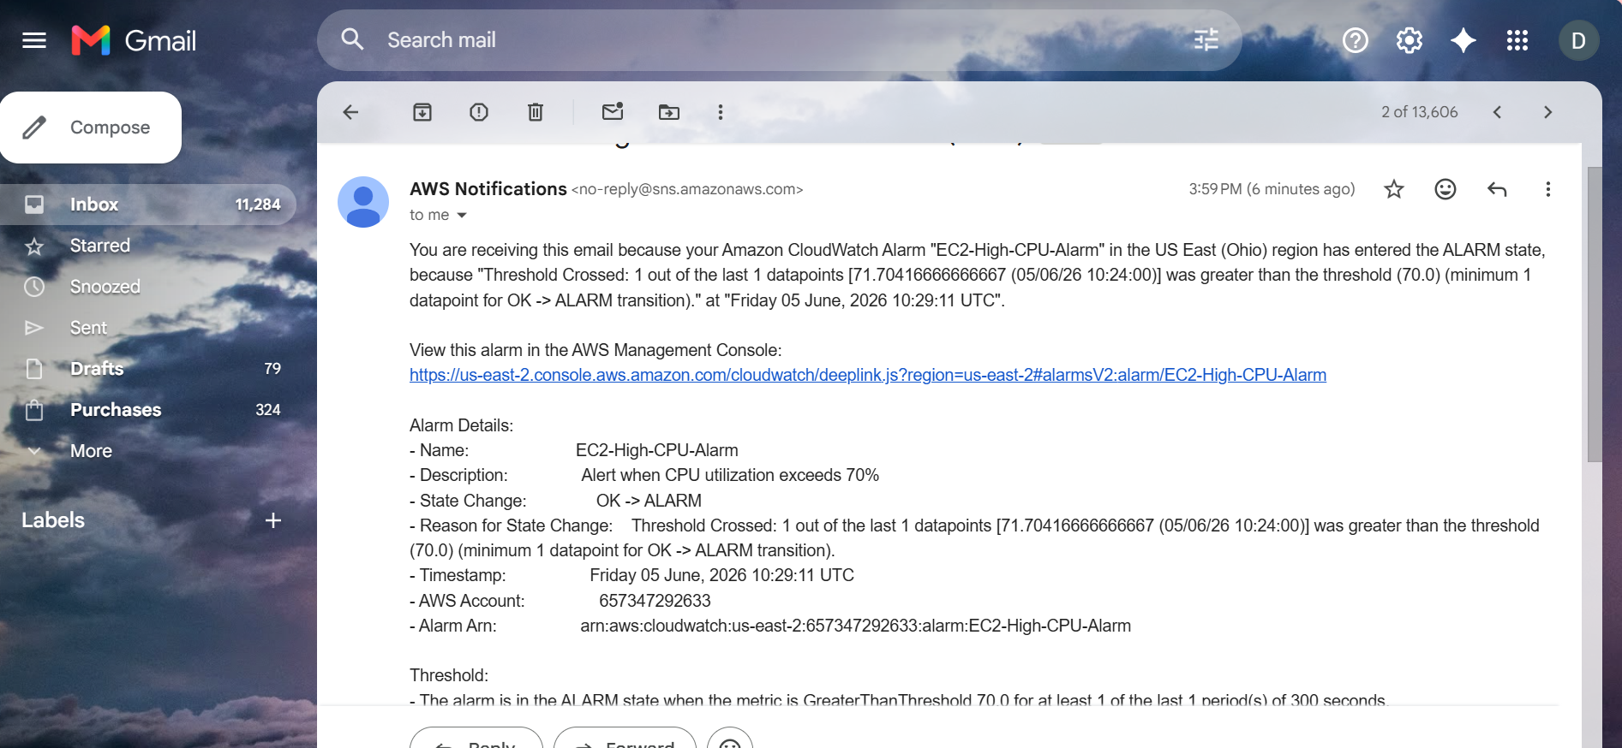
Architecture
EC2 Instance
│
▼
CloudWatch Metrics
│
▼
CloudWatch Alarm
│
▼
SNS Topic (EC2-CPU-Alerts)
│
▼
Email Subscription
│
▼
Email Notification

Result
Successfully created a CloudWatch alarm to monitor EC2 CPU utilization.
Verified:
✔ CPU Utilization Monitoring
✔ Alarm Threshold Set to 70%
✔ SNS Integration
✔ Email Notifications
✔ Alarm Trigger Validation

Conclusion
Amazon CloudWatch Alarm was successfully configured to monitor EC2 CPU utilization. When CPU usage exceeded 70%, the alarm changed to the ALARM state and an email notification was sent through Amazon SNS. This implementation enables proactive monitoring and rapid response to high CPU utilization events.
Task 5: Create a CloudWatch Dashboard to Monitor Tomcat Service Status and Send Alerts
Objective
To monitor the Apache Tomcat service running on an EC2 instance using Amazon CloudWatch, visualize the service status through a CloudWatch Dashboard, and receive email notifications whenever the Tomcat service stops or becomes unavailable.

AWS Services Used
- Amazon EC2
- Amazon CloudWatch
- Amazon CloudWatch Agent
- Amazon SNS
- Apache Tomcat

Pre-Requisites
- Running EC2 Instance.
- Apache Tomcat installed and running.
- CloudWatch Agent installed.
- SNS Topic (CloudTrail-Alerts) with confirmed email subscription.
- IAM role attached to EC2 with CloudWatch permissions.

Implementation Steps
Step 1: Verify Tomcat Service Status
Connected to the EC2 instance:
ssh -i mykey.pem ec2-user@<public-ip>
Verified Tomcat service status:
sudo systemctl status tomcat
Output:
Active: active (running)
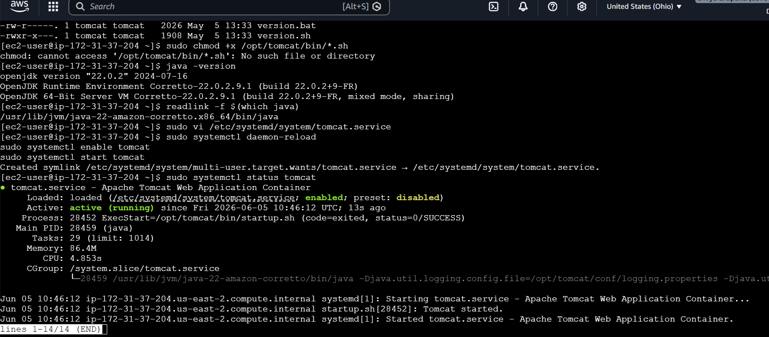
Step 2: Install CloudWatch Agent
Installed CloudWatch Agent:
sudo yum install amazon-cloudwatch-agent -y
Verified installation:
amazon-cloudwatch-agent-ctl -a status
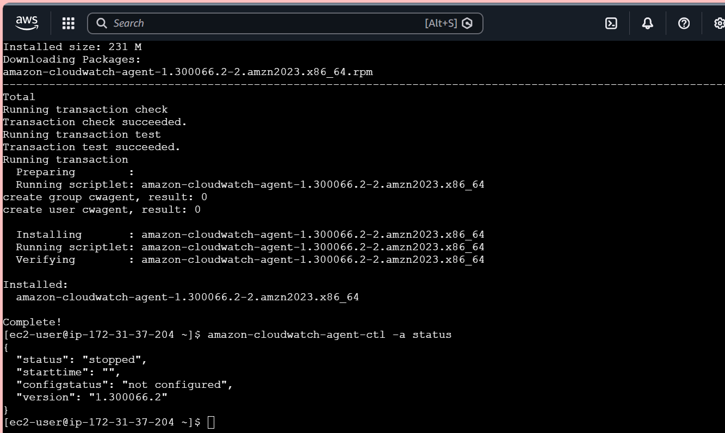
Step 3: Create Tomcat Monitoring Script
Created a custom script:
sudo vi /opt/tomcat-status.sh
Script content:
#!/bin/bash

if systemctl is-active --quiet tomcat
then
aws cloudwatch put-metric-data \
--metric-name TomcatStatus \
--namespace Custom/Tomcat \
--value 1
else
aws cloudwatch put-metric-data \
--metric-name TomcatStatus \
--namespace Custom/Tomcat \
--value 0
fi
Provided execute permissions:
chmod +x /opt/tomcat-status.sh
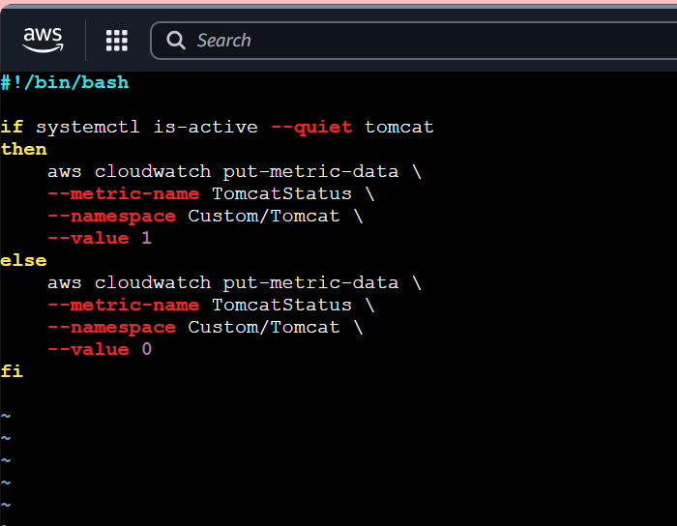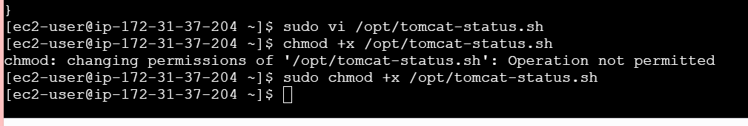
Step 4: Schedule Metric Collection
Configured cron job:
crontab -e
Added:
*/1 * * * * /opt/tomcat-status.sh
Purpose:
- Send Tomcat status metric every minute.
- Value = 1 → Tomcat Running
- Value = 0 → Tomcat Stopped
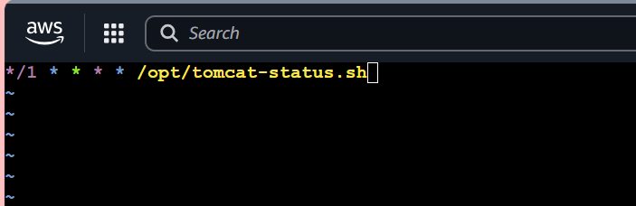
Step 5: Verify Custom Metric
Navigated to:
CloudWatch → Metrics → Custom Namespaces
Selected:
Custom/Tomcat
Verified metric:
TomcatStatus
Expected values:
Value | Meaning
1 | Running
0 | Stopped
Evidence: Screenshot of Custom Metric.
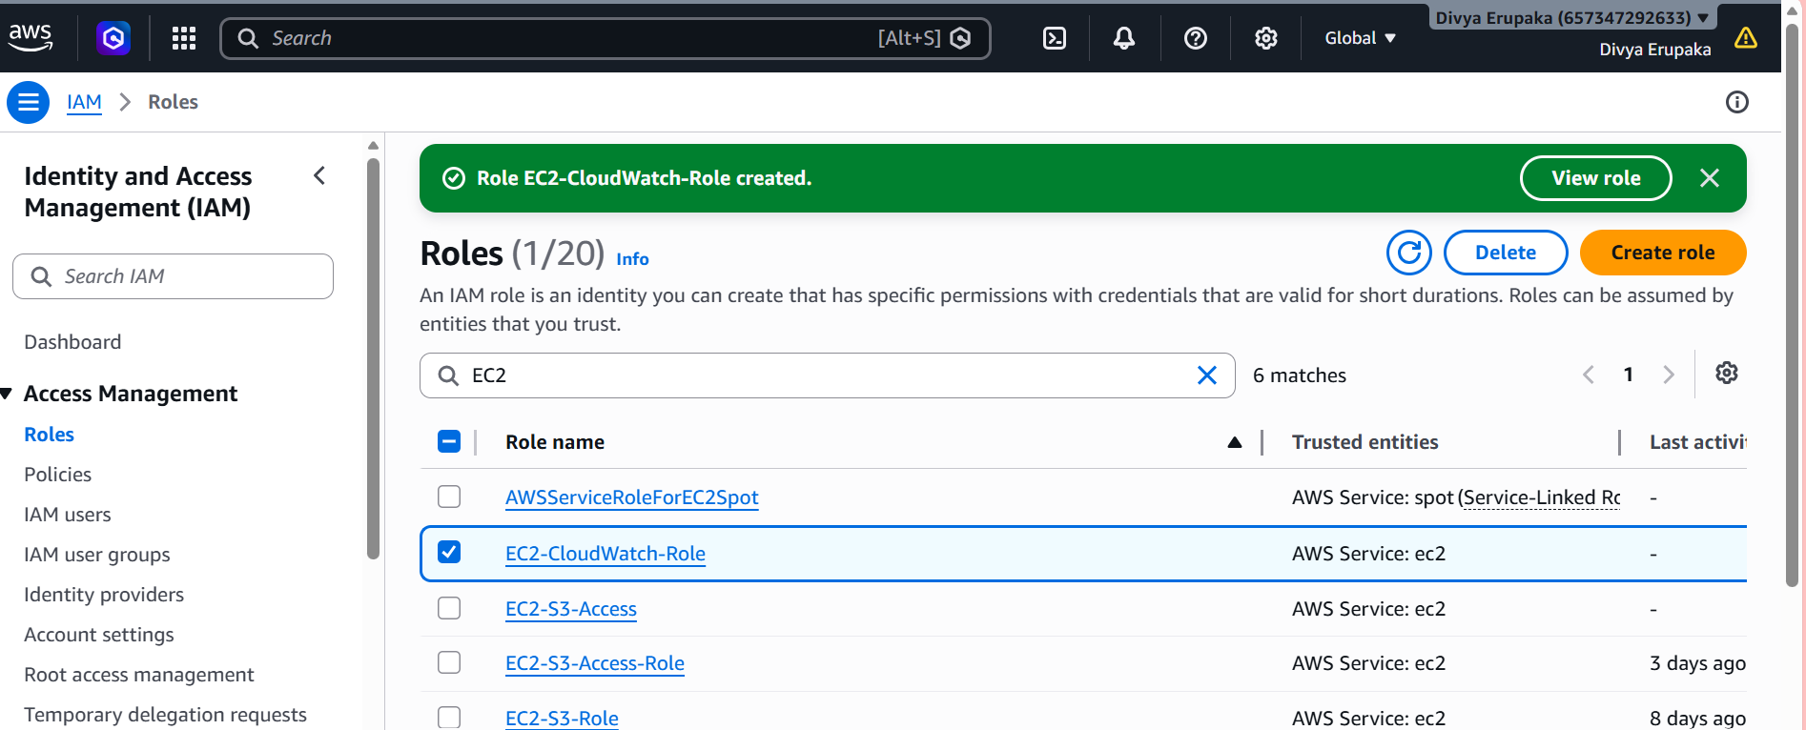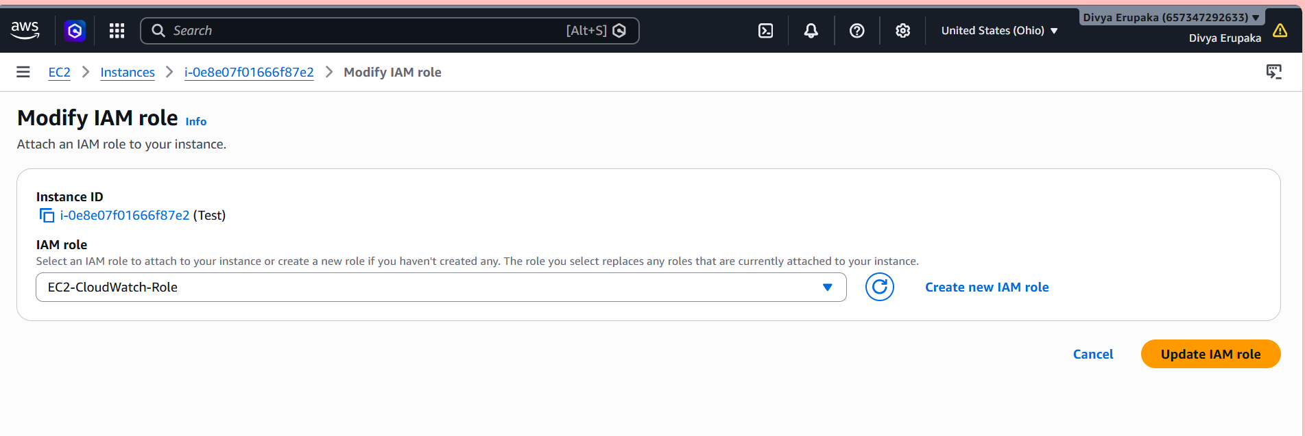
Step 6: Create CloudWatch Dashboard
- Opened CloudWatch Dashboard.
- Clicked Create Dashboard.
- Entered Dashboard Name:
Tomcat-Monitoring-Dashboard
- Added widget:
Metric | Namespace
TomcatStatus | Custom/Tomcat
- Saved Dashboard.
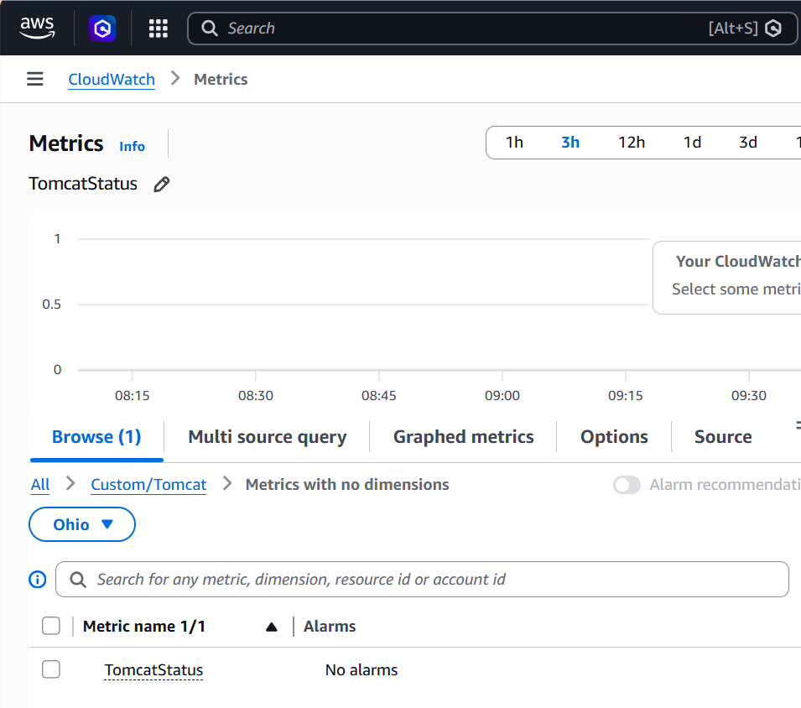Step 7: Create CloudWatch Alarm
Navigated to:
CloudWatch → Alarms → Create Alarm
Selected metric:
Custom/Tomcat → TomcatStatus
Configured:
Parameter | Value
Threshold Type | Static
Condition | Less Than
Threshold Value | 1
Evaluation Period | 1 Minute
Meaning:
- Alarm triggers if Tomcat status becomes 0.
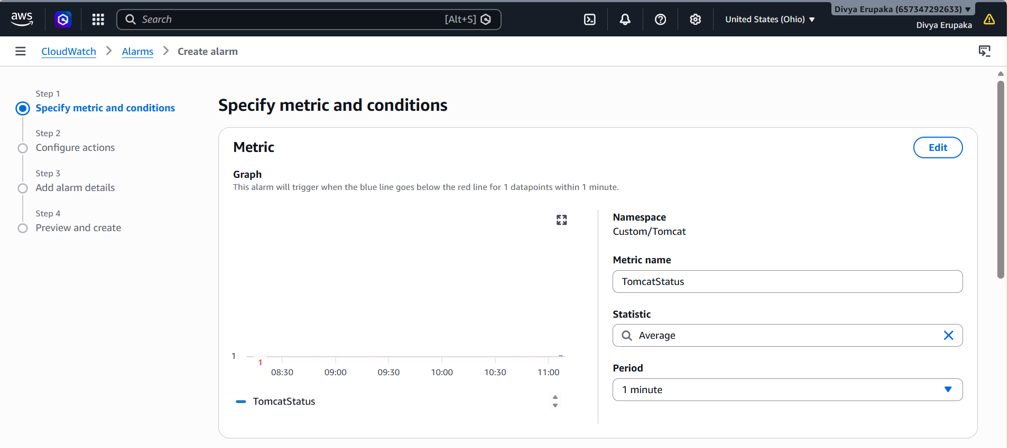
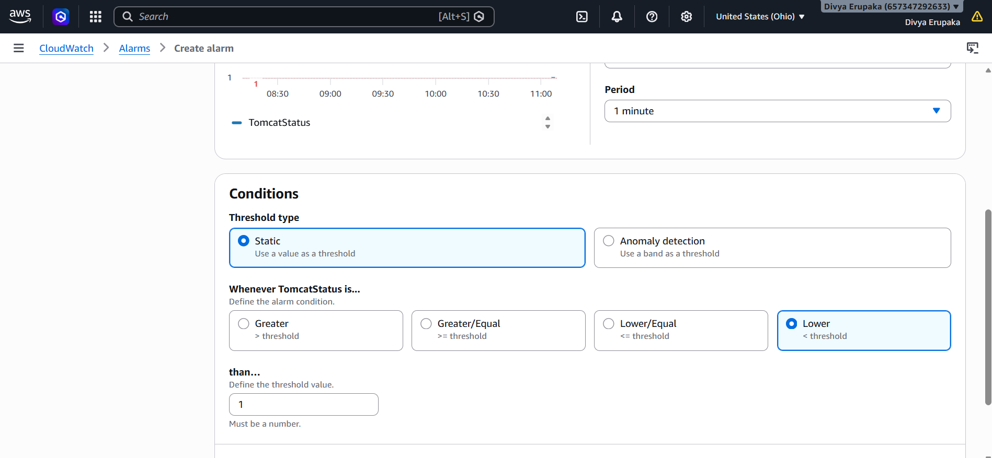Step 8: Configure SNS Notification
Selected:
Send notification to existing SNS Topic
SNS Topic:
CloudTrail-Alerts
Alarm Name:
Tomcat-Service-Down
Created Alarm.
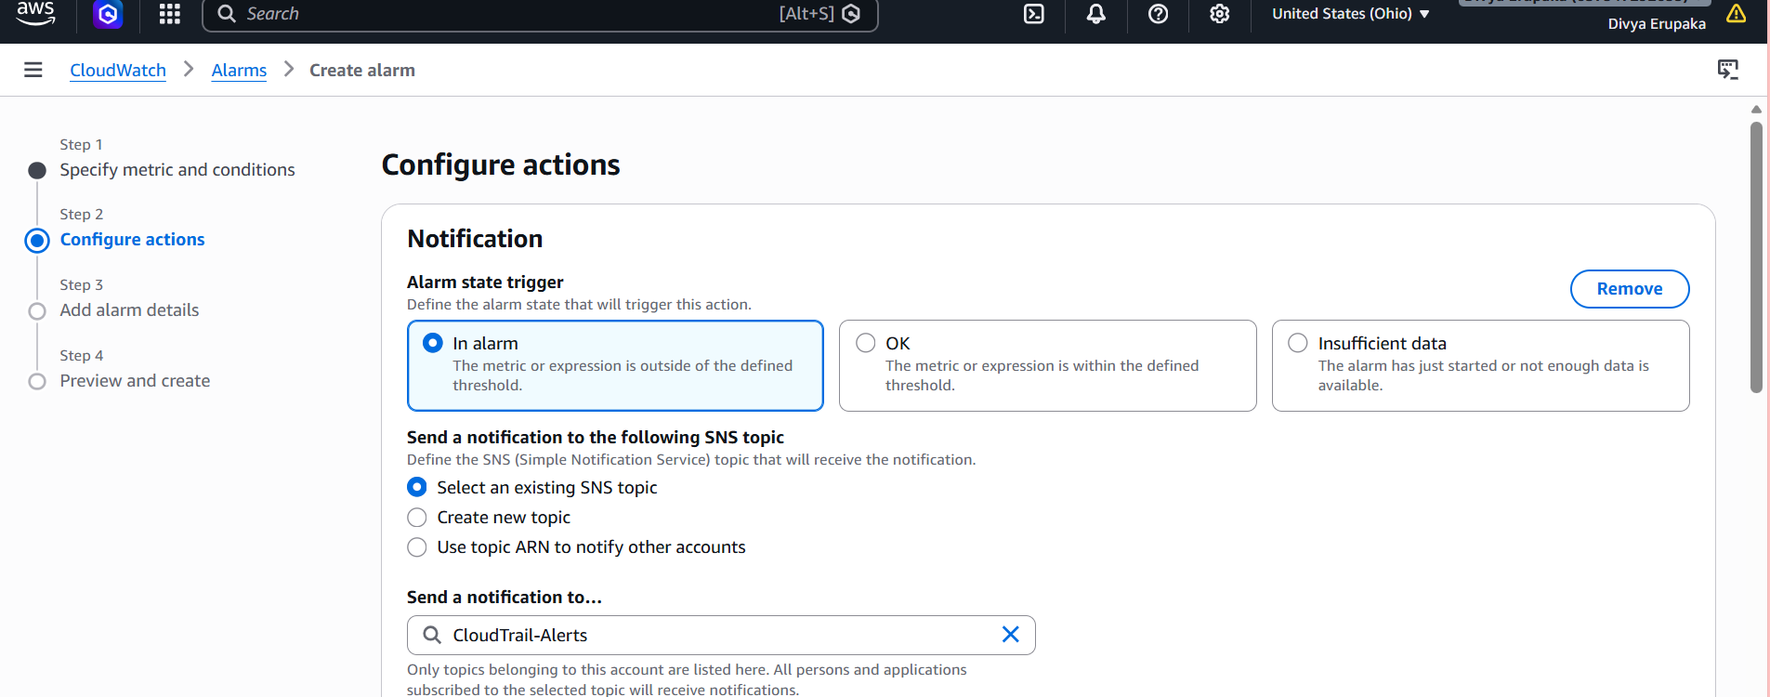
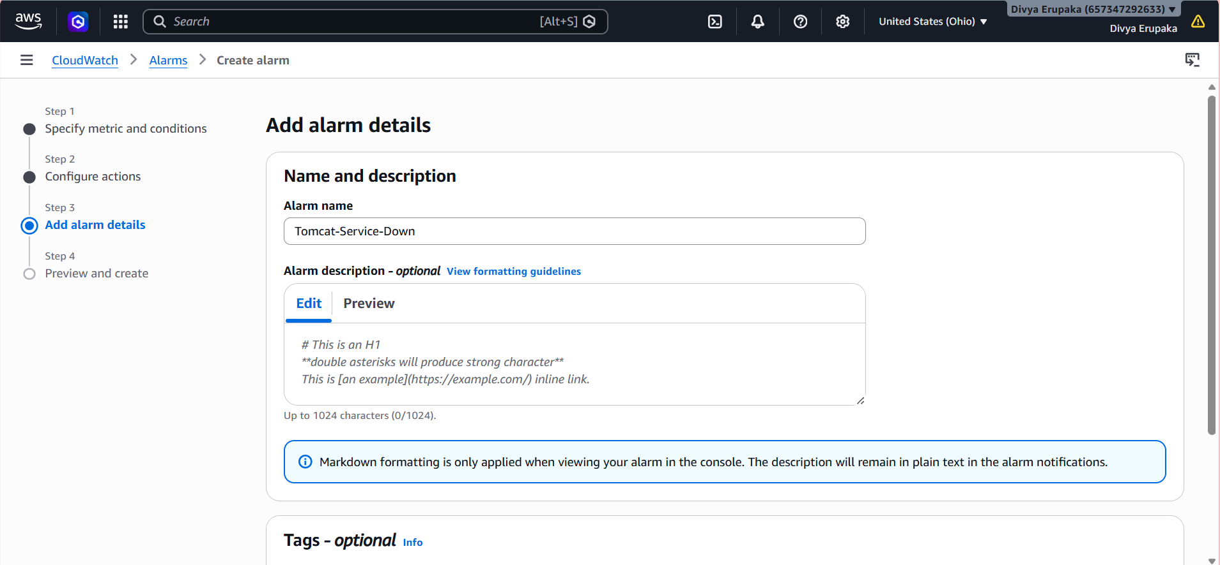Step 9: Test the Alarm
Stopped Tomcat:
sudo systemctl stop tomcat
Verified:
sudo systemctl status tomcat
Output:
inactive (dead)
Observed:
- Custom metric changed from 1 to 0.
- CloudWatch Alarm entered ALARM state.
- Email notification received.
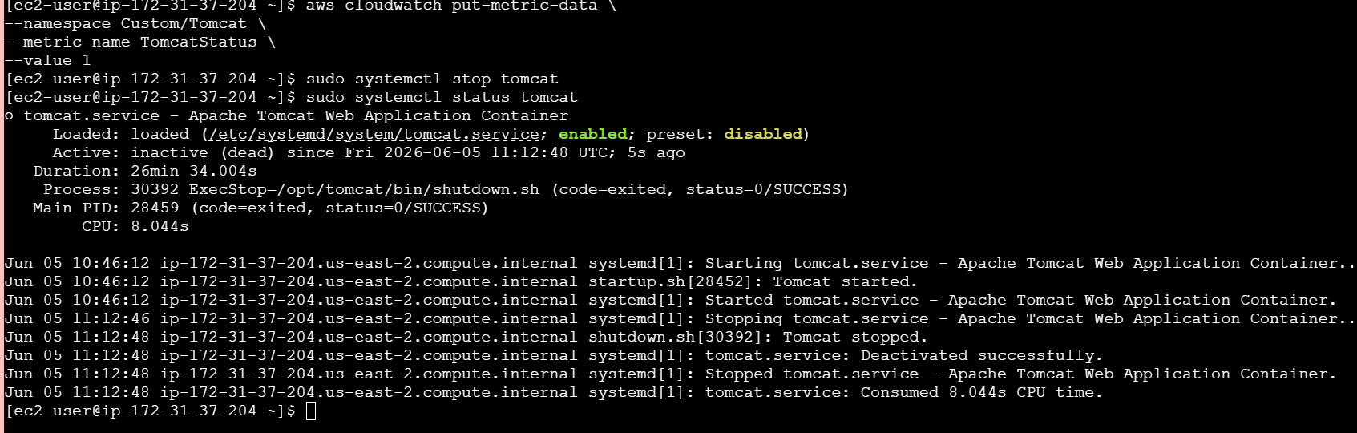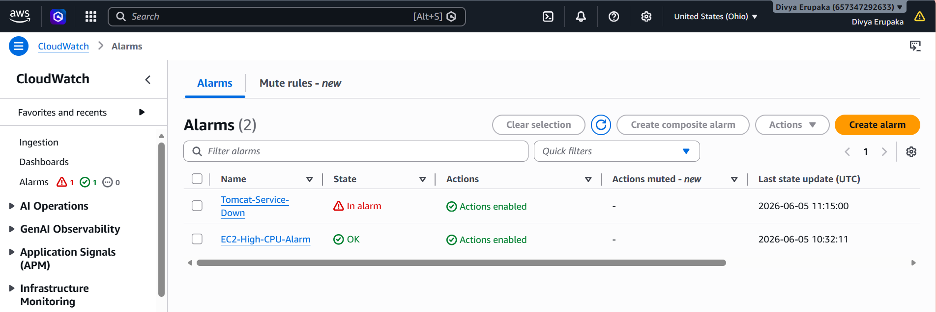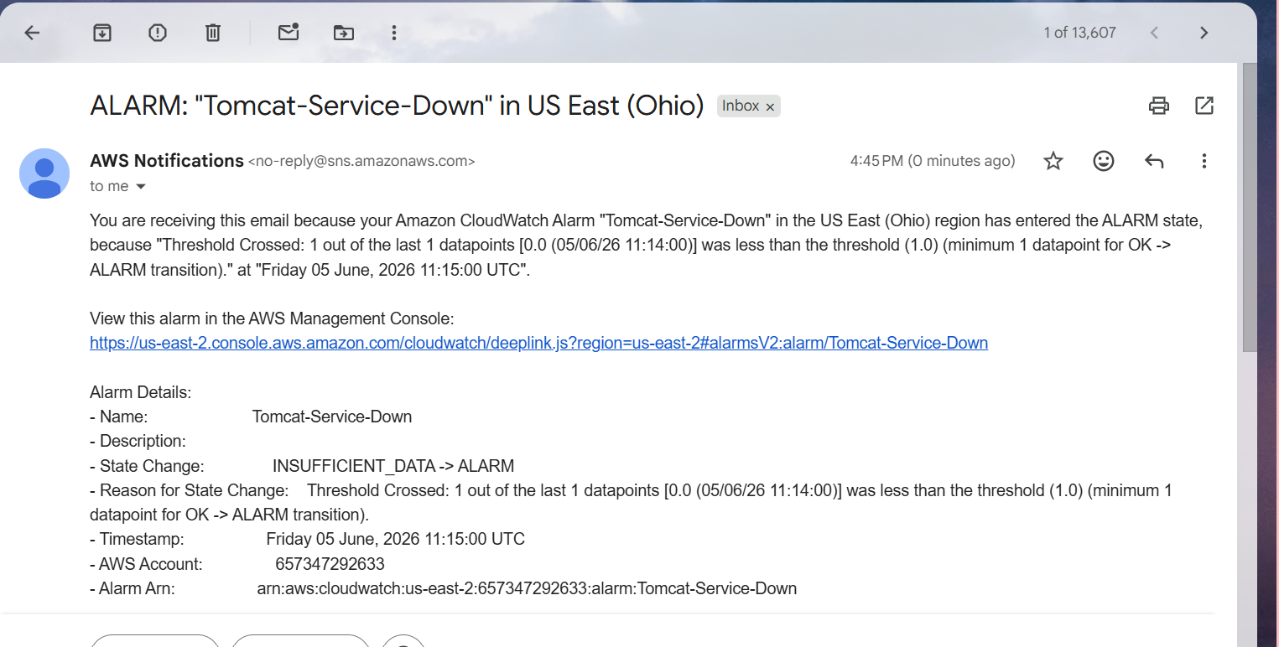
Architecture
EC2 Instance
│
▼
Tomcat Service
│
▼
Custom CloudWatch Metric
│
▼
CloudWatch Dashboard
│
▼
CloudWatch Alarm
│
▼
SNS Topic (CloudTrail-Alerts)
│
▼
Email Notification

Result
Successfully configured monitoring for the Apache Tomcat service using Amazon CloudWatch.
Verified:
✔ Tomcat service status monitoring
✔ Custom CloudWatch metric creation
✔ Dashboard visualization
✔ CloudWatch alarm configuration
✔ SNS email notification
✔ Successful alert generation when Tomcat service stopped

Conclusion
Amazon CloudWatch was successfully configured to monitor the Apache Tomcat service running on an EC2 instance. A custom metric was created to track service status, displayed through a CloudWatch Dashboard, and integrated with CloudWatch Alarms and SNS notifications. The solution provides real-time visibility into application availability and immediately alerts administrators when the Tomcat service becomes unavailable.
Task 6: Create a CloudWatch Dashboard and Monitor Nginx Service to Send Alerts if Nginx is Not Running
Objective To monitor the Nginx service running on an EC2 instance using Amazon CloudWatch, create a dashboard to visualize service status, and receive email alerts whenever the Nginx service stops or becomes unavailable.

AWS Services Used
- Amazon EC2
- Amazon CloudWatch
- Amazon SNS
- IAM
- Nginx Web Server

Pre-Requisites
- Running EC2 Instance
- Nginx Installed and Running
- IAM Role attached to EC2 with CloudWatch permissions
- SNS Topic (CloudTrail-Alerts) with confirmed email subscription
- CloudWatch access

Implementation Steps
Step 1: Verify Nginx Service
Connect to the EC2 instance:
ssh -i your-key.pem ec2-user@<public-ip>
Check Nginx status:
sudo systemctl status nginx
Expected Output:
Active: active (running)
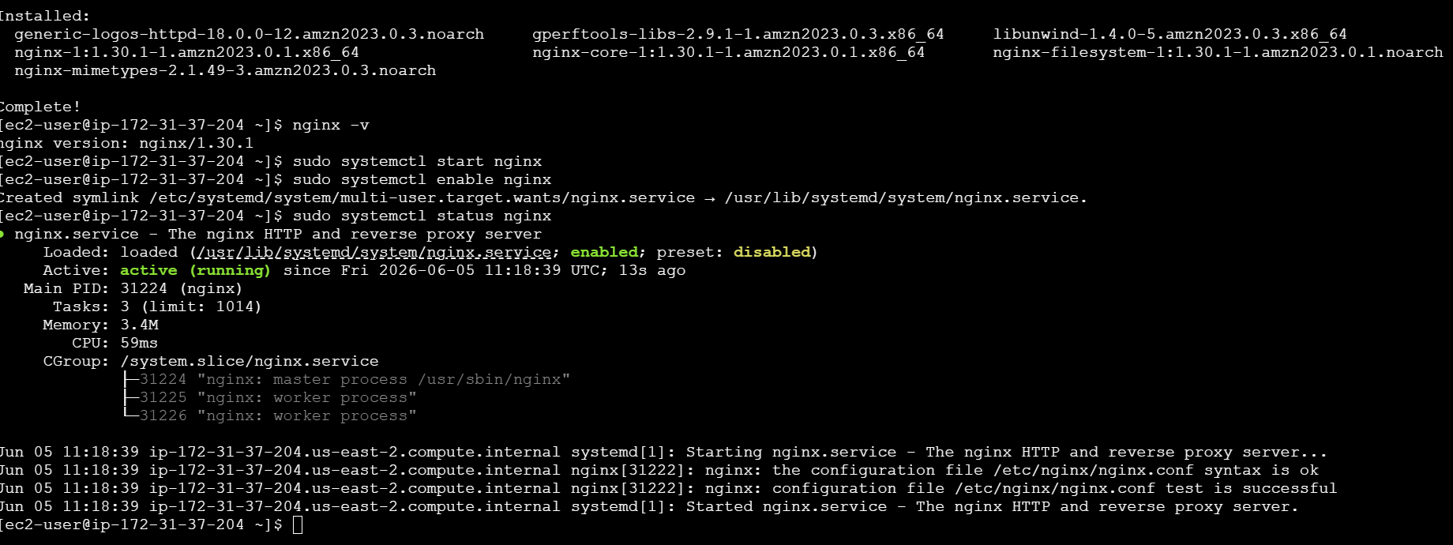Step 2: Create Nginx Monitoring Script
Create a script:
sudo vi /opt/nginx-status.sh
Add the following content:
#!/bin/bash

if systemctl is-active --quiet nginx
then
aws cloudwatch put-metric-data \
--namespace Custom/Nginx \
--metric-name NginxStatus \
--value 1
else
aws cloudwatch put-metric-data \
--namespace Custom/Nginx \
--metric-name NginxStatus \
--value 0
fi
Save and exit.
Provide execute permission:
sudo chmod +x /opt/nginx-status.sh
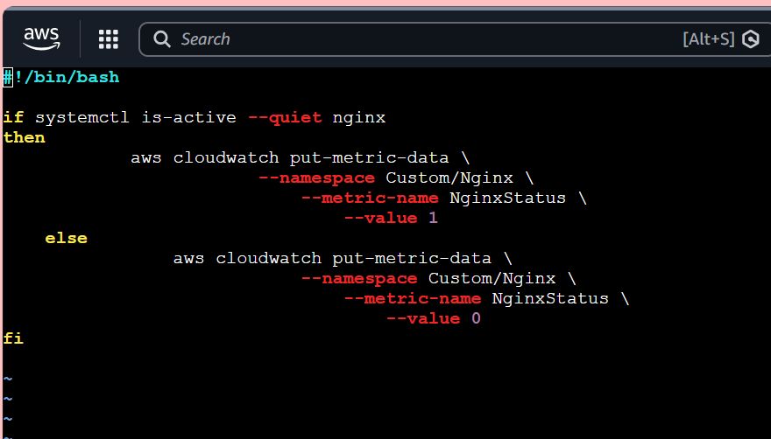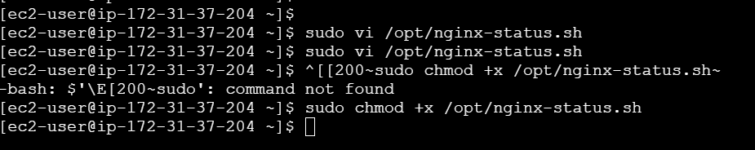
Step 3: Configure Cron Job
Edit crontab:
crontab -e
Add:
*/1 * * * * /opt/nginx-status.sh
Purpose:
- Metric Value = 1 → Nginx Running
- Metric Value = 0 → Nginx Stopped
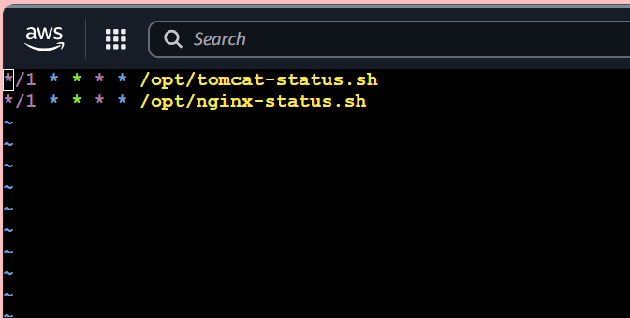
Step 4: Verify Custom Metric
Wait 2–3 minutes after cron executes.
Navigate to:
CloudWatch → Metrics → All Metrics → Custom Namespaces
Verify namespace:
Custom/Nginx
Verify metric:
NginxStatus
Expected Values:
Value | Meaning
1 | Running
0 | Stopped
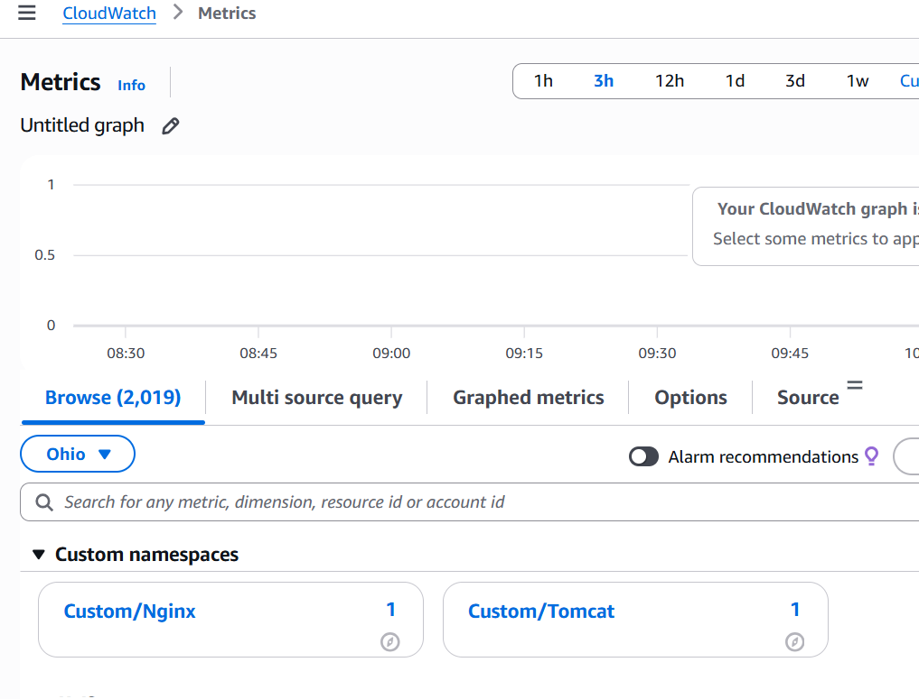Step 5: Create CloudWatch Dashboard
- Open CloudWatch.
- Select Dashboards.
- Click Create Dashboard.
Dashboard Name:
Nginx-Monitoring-Dashboard
- Add a Line Widget.
- Select:
Custom/Nginx
- Choose:
NginxStatus
- Save Dashboard.
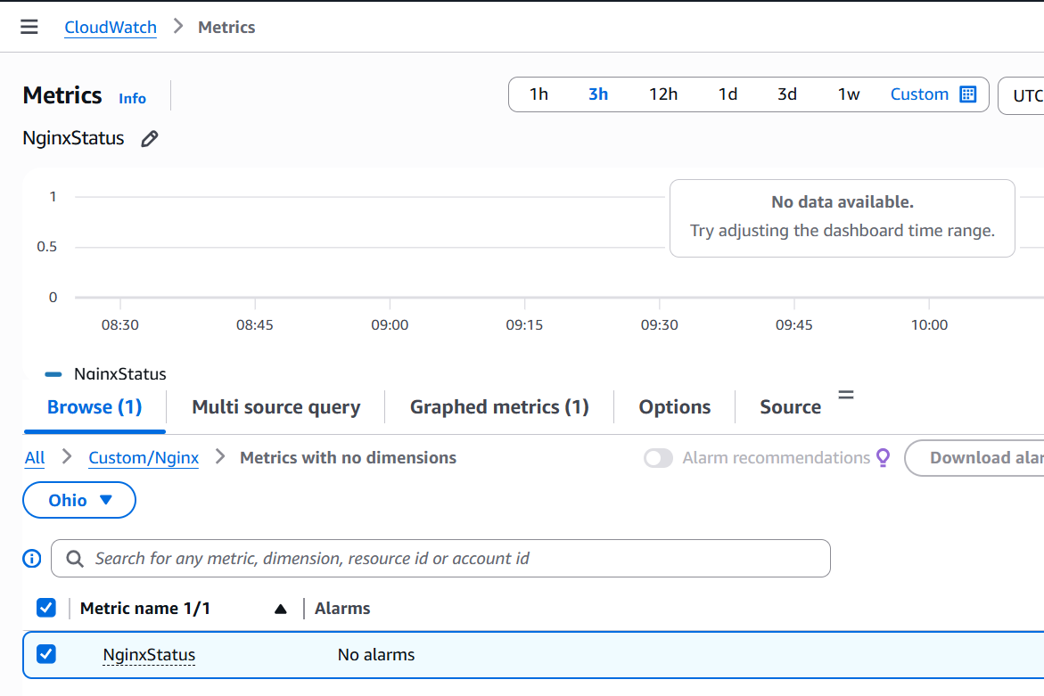
Step 6: Create CloudWatch Alarm
Navigate to:
CloudWatch → Alarms → Create Alarm
Select Metric:
Custom/Nginx
→ NginxStatus
Configure:
Parameter | Value
Statistic | Average
Period | 1 Minute
Threshold Type | Static
Condition | Less Than
Threshold Value | 1
Meaning:
Alarm triggers whenever Nginx status becomes 0.
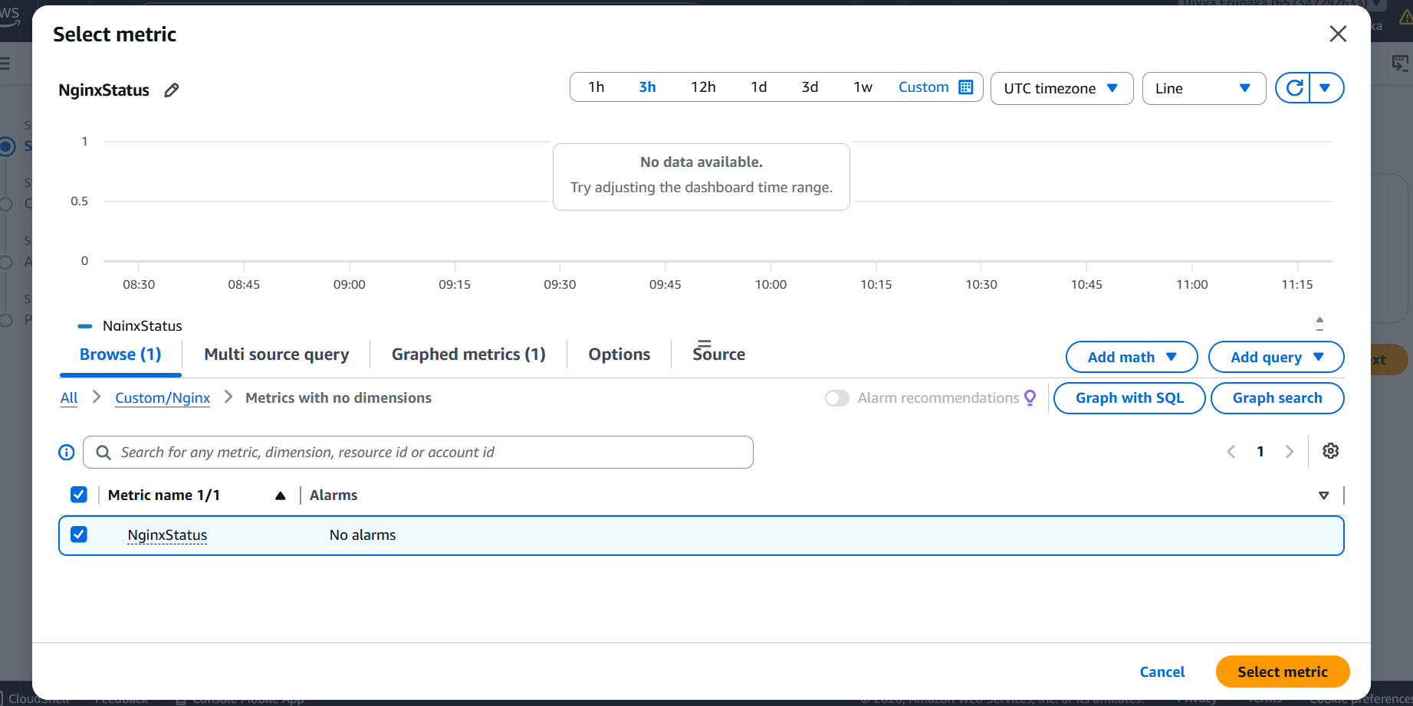Step 7: Configure SNS Notification
Select:
Send notification to an existing SNS topic
Choose SNS Topic:
CloudTrail-Alerts
Alarm Name:
Nginx-Service-Down
Create Alarm.
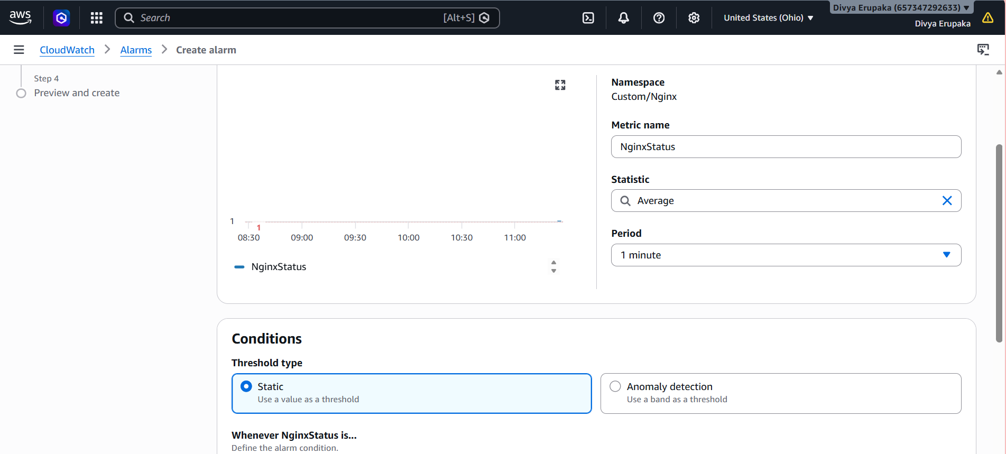
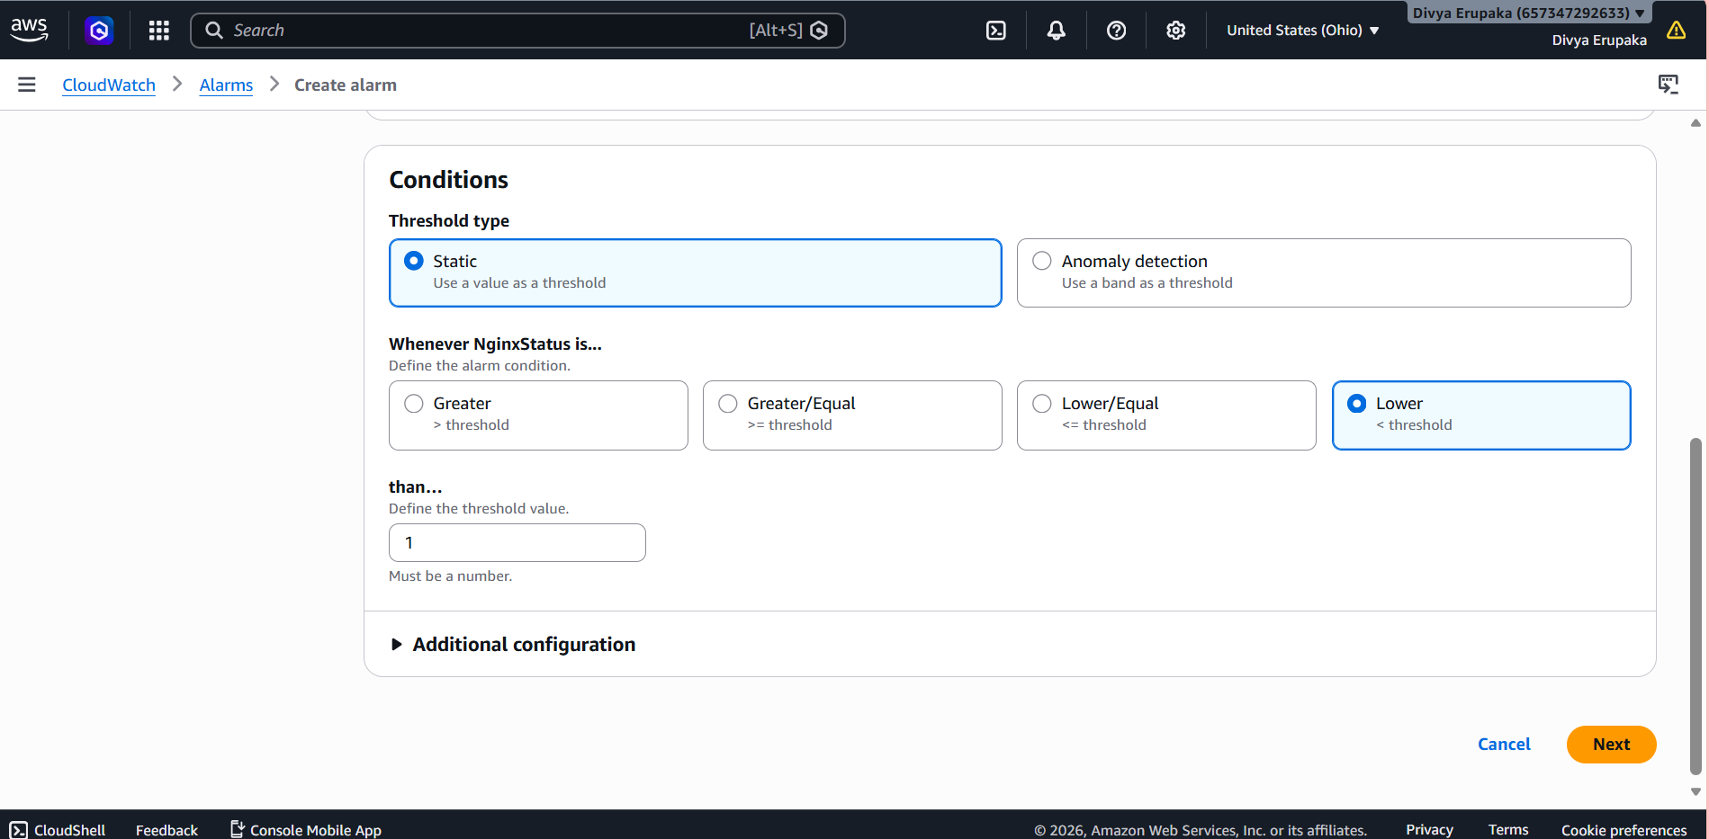
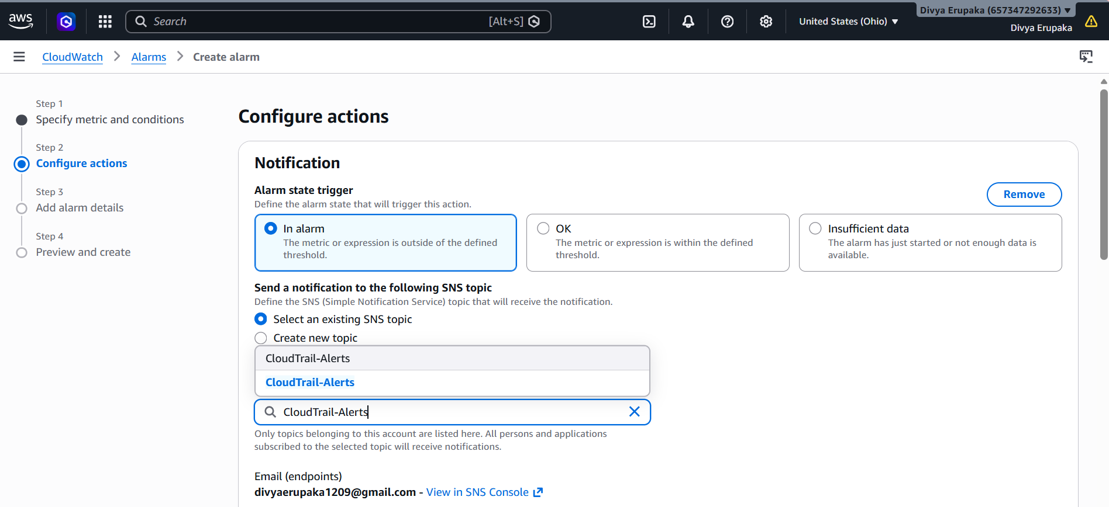
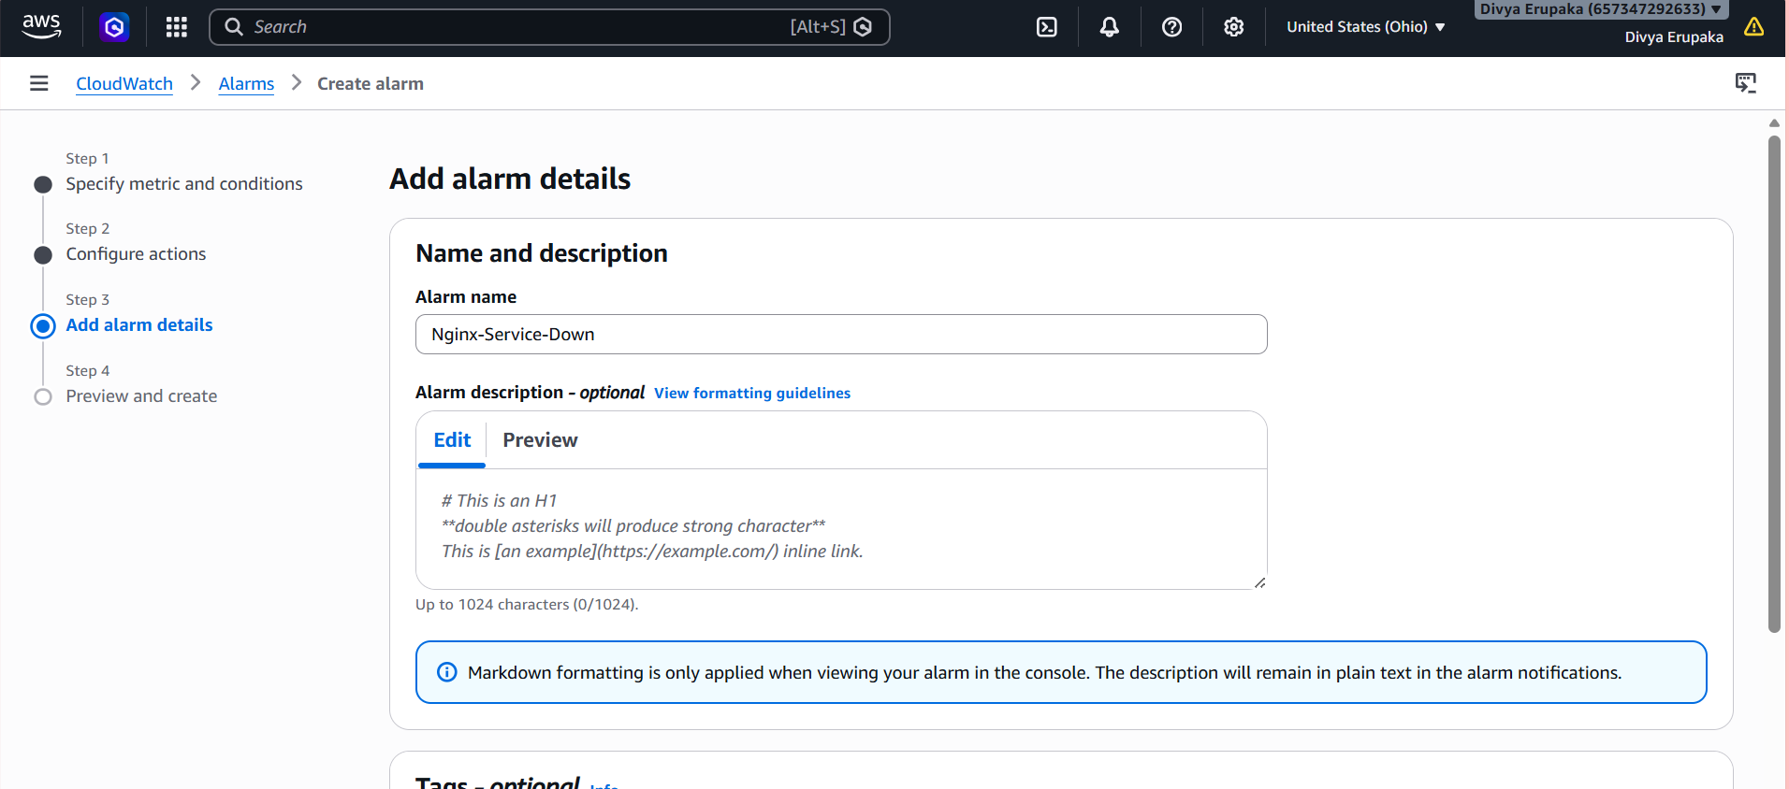
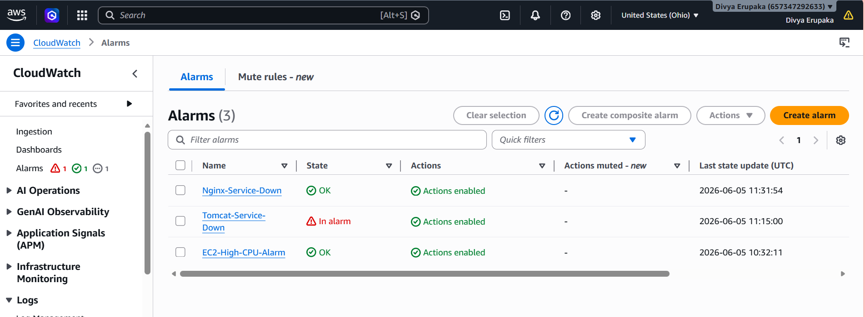Step 8: Test Monitoring
Stop Nginx:
sudo systemctl stop nginx
Verify:
sudo systemctl status nginx
Expected Output:
inactive (dead)
Wait 1–2 minutes.
Observe:
- NginxStatus changes from 1 to 0.
- Alarm state changes from OK to ALARM.
- Email notification is received.
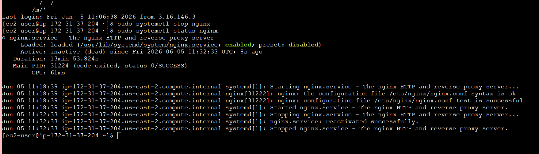
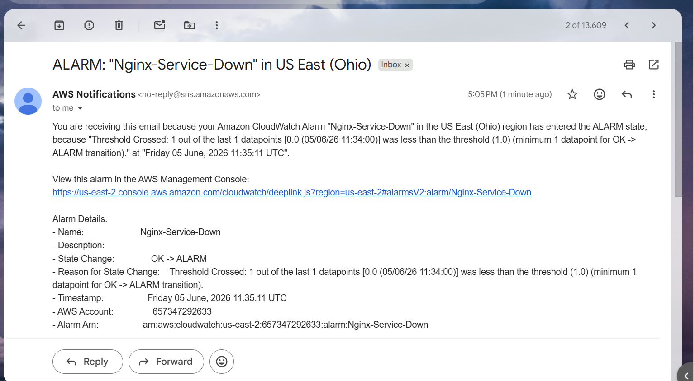Architecture
EC2 Instance
│
▼
Nginx Service
│
▼
Custom CloudWatch Metric
(Custom/Nginx)
│
▼
CloudWatch Dashboard
│
▼
CloudWatch Alarm
│
▼
SNS Topic (CloudTrail-Alerts)
│
▼
Email Notification

Result
Successfully configured monitoring for the Nginx service using Amazon CloudWatch.
Verified:
✔ Nginx service status monitoring
✔ Custom metric creation
✔ Dashboard visualization
✔ Alarm configuration
✔ SNS email notifications
✔ Alert generation when Nginx service stopped

Conclusion
Amazon CloudWatch was successfully configured to monitor the Nginx service running on an EC2 instance. A custom metric was created to track service availability, displayed through a CloudWatch Dashboard, and integrated with CloudWatch Alarms and SNS notifications. The solution provides real-time monitoring and immediate alerts whenever the Nginx service becomes unavailable.

